**Module-2: FSx Assignment 4**

**Problem Statement:**

You work for XYZ Corporation and the current requirement in the organization is for faster file sharing, which can also help in data replication from On-Premises infrastructure.

**You have been asked to:**

1. Create an FSx file system for a windows file server

a. Make sure you have AWS Managed Active Directory with a valid domain name.

b. Connect it to your Windows EC2 server.

2. Create an FSx file system for Lustre and attach it to an Amazon Linux 2 instance.

**Problem 1 (a) Solution:** Make sure you have AWS Managed Active Directory with a valid domain name.

**Step 1: Go** tothe **“Services” section** & **Search** the **“FSx”. Click** on **the “FSx”.**

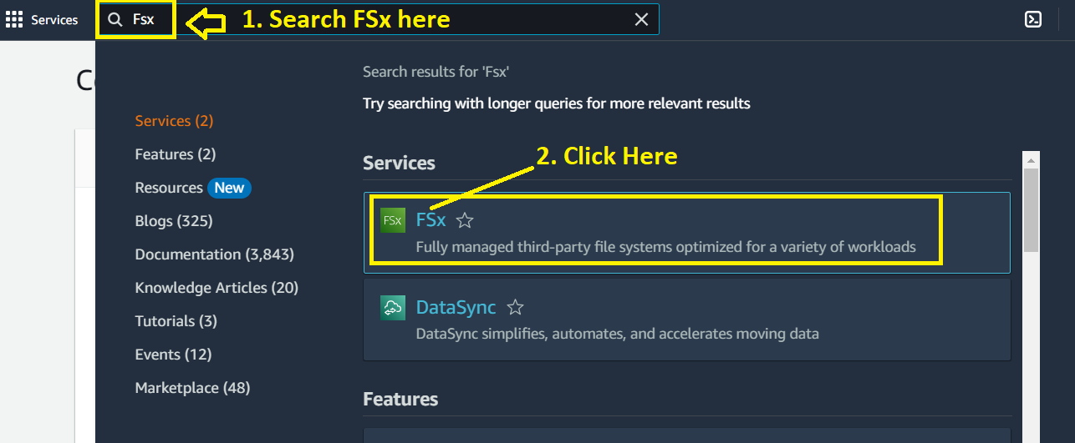

**Step 2: Click** on the **“Create File System”.**

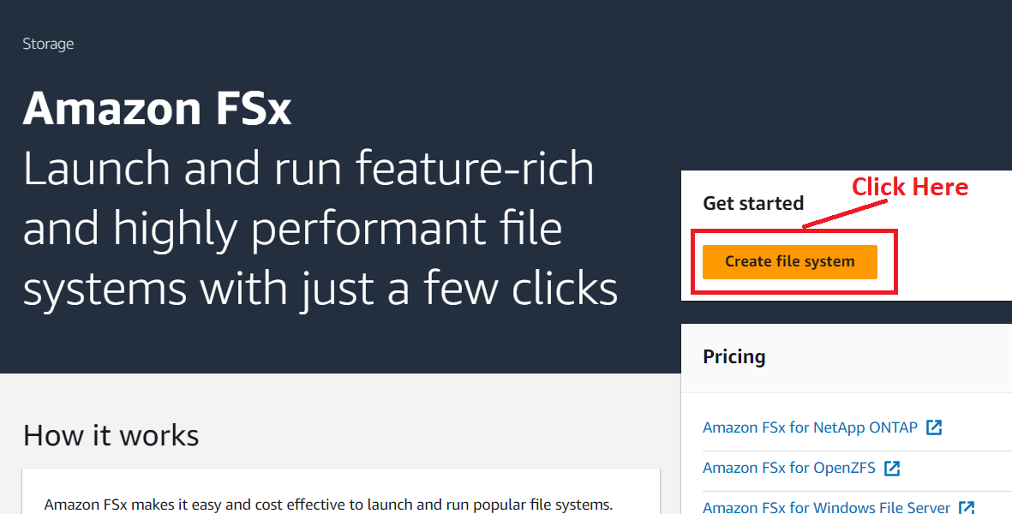

**Step 3: Choose** the **“Amazon FSx for Window File Server”** server.

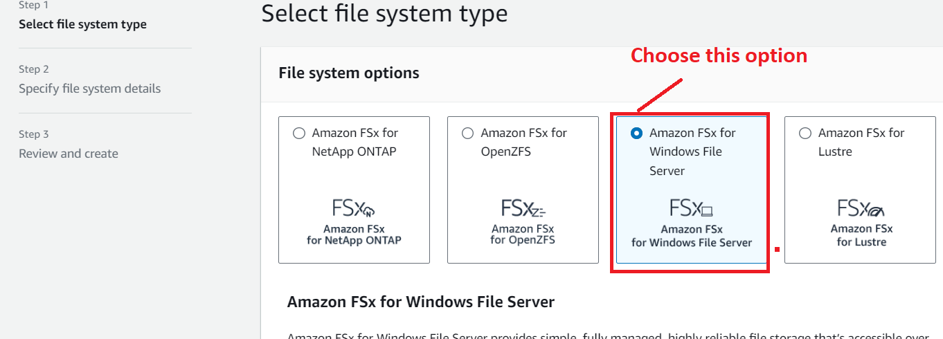

**Step 4: Click** onthe **“Next”.**

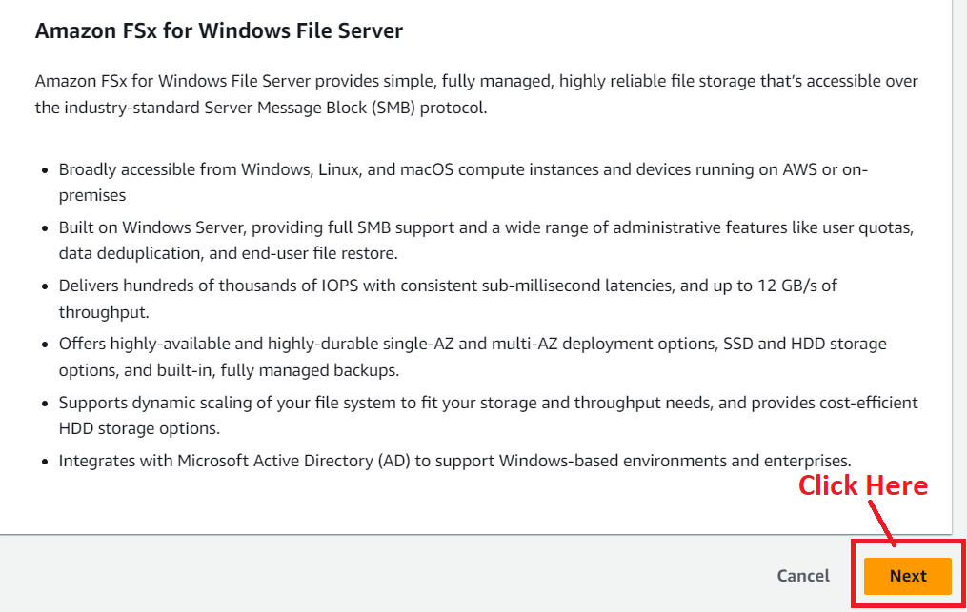

**Step 5: In** the **“File system details”, we** will **choose** the **following options** here:

**File system name – optional:** FSx-For-Windows

**Deployment Type –** Single-AZ2-1

**Storage type –** SSD

**SSD Storage Capacity** **–** 32 GiB

**Provisioned SSD IOPS** **–** Automatic (3 IOPS per GiB of SSD Storage)

**Throughput capacity-** 32 MB/s (recommended)

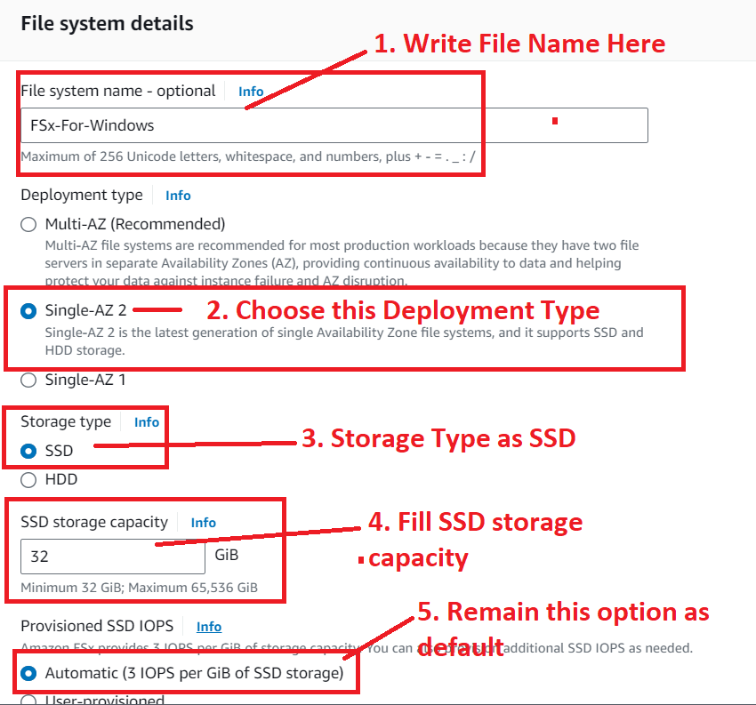

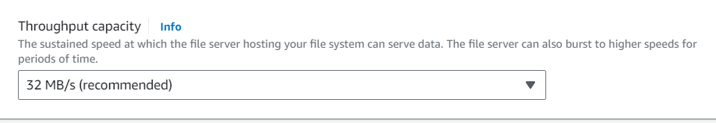

**Step 6: Leave** the **“Network & security” as it is. We** have **selected** the **VPC,** the **“VPC Security Group & Subnet”** as **by default created** in **AWS account.**

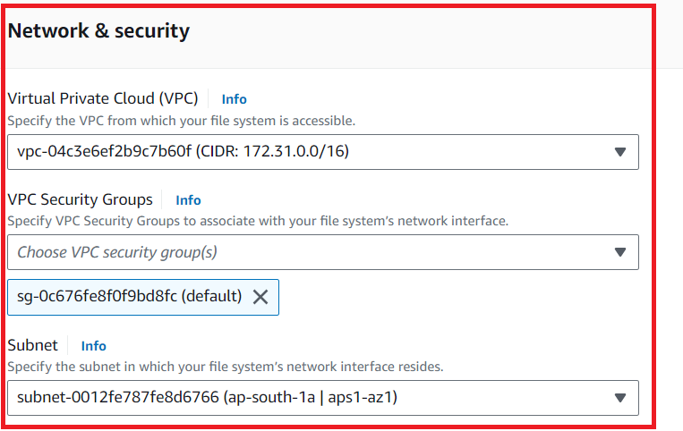

**Step 7: In Windows authentication, we** will **choose “AWS Managed Microsoft Active Directory”.**

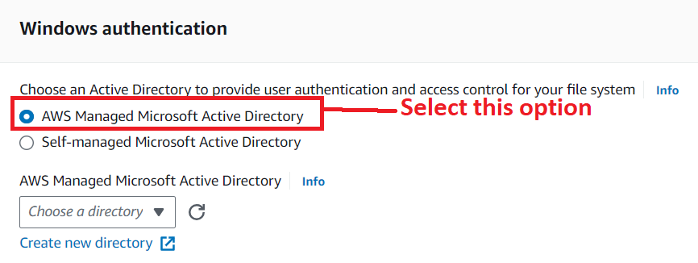

**Step 8: We** don’t **have** any **AWS Managed Microsoft Active Directory. So, we** will **create** a **new directory. Click** onthe **“Create new directory”** in the **blue hyperlink.**

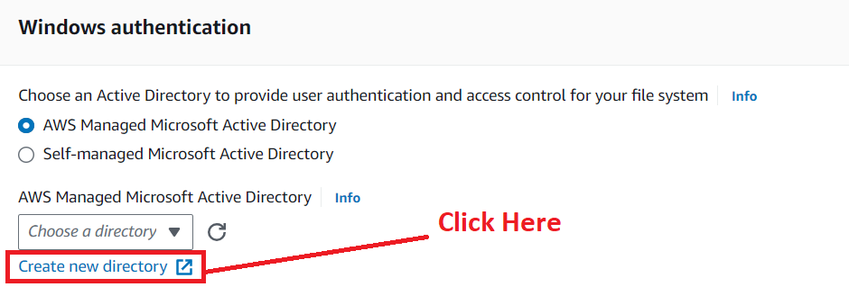

**Step 9: You** will be **redirected** tothe **“Setup Directory page”. Choose** the **“AWS Managed Microsoft AD”** option& **click** onthe **“Next”.**

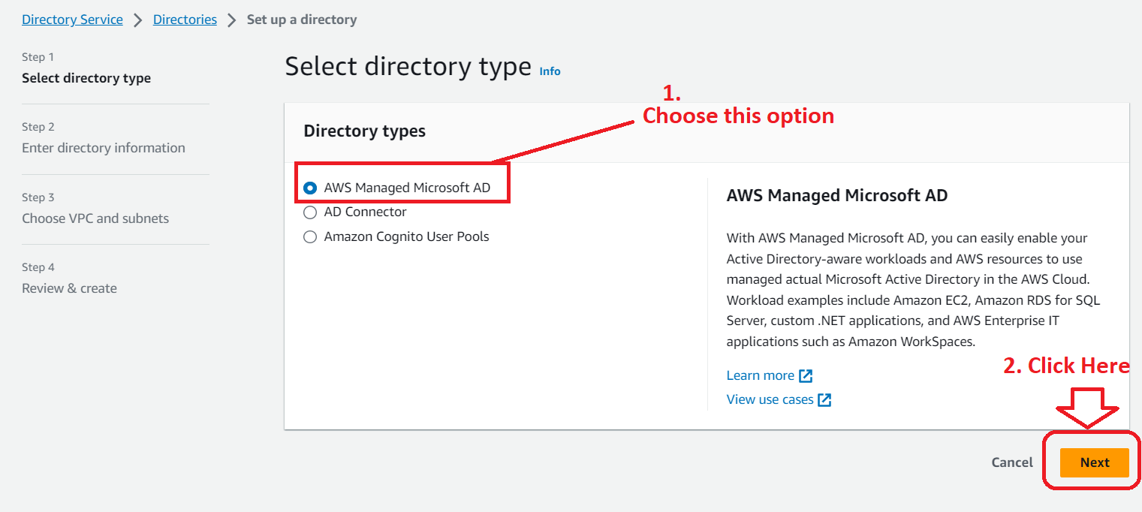

**Step 10: In** the **“Directory Information”, choose** the **“Edition”** as **“Standard Edition”.**

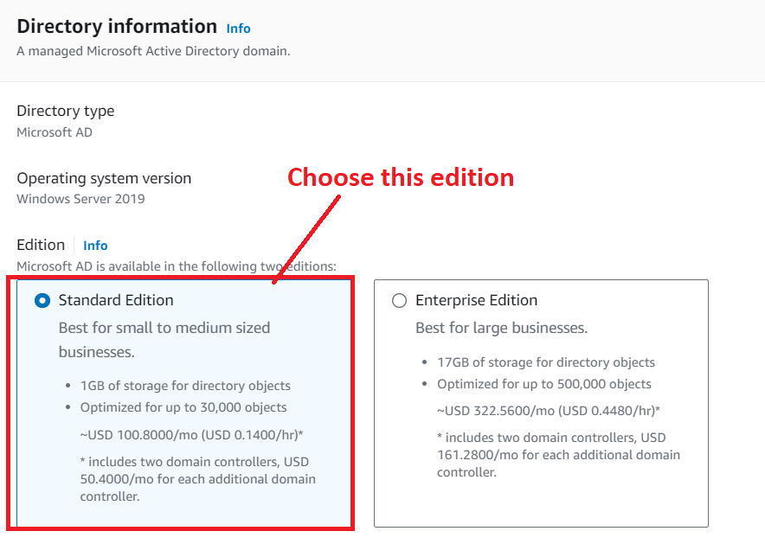

**Step 11: Choose** the **“Directory DNS Name”** as **“fsx.ad”.** The **“Directory NetBIOS”** as **“FSX-Assignment”** & **you can** also **provide** the **“Directory description”** as **well.**

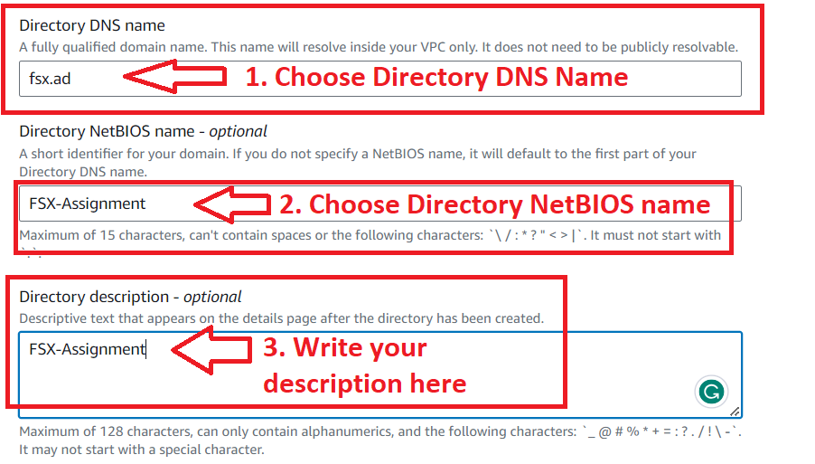

**Step 12: Choose** the **“Admin password”** & **also confirm** your **password over here. Click** on the **“Next”.**

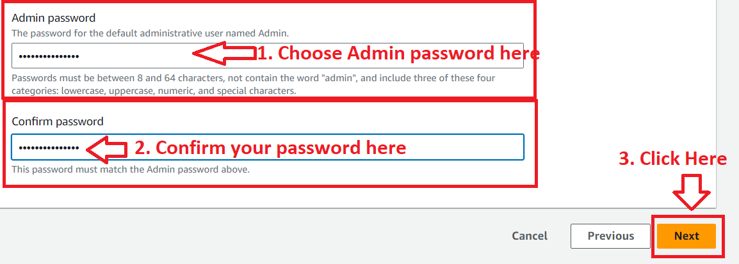

**Step 13: In** the **“Choose VPC and subnets”** option, **Choose** the **“VPC”** as **by default created** & **the subnets** as **“No preference”. Click** onthe **“Next”.**

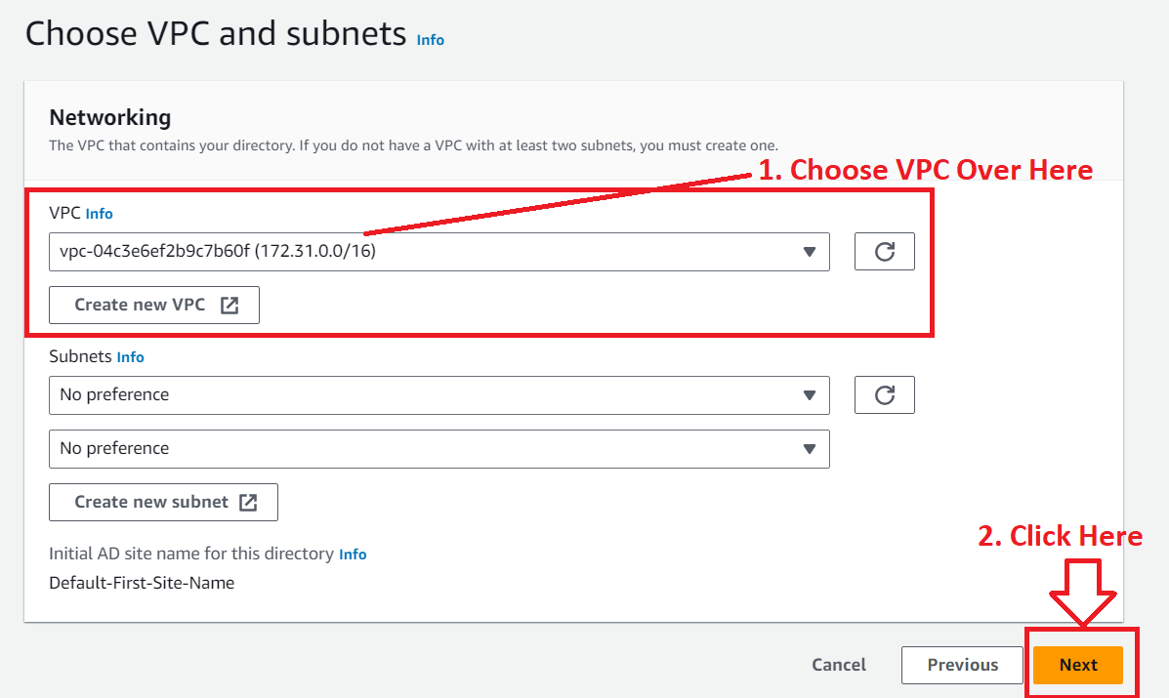

**Step 14: In** the **“Review & Create” section, it** will **show** your **“Directory details”.**

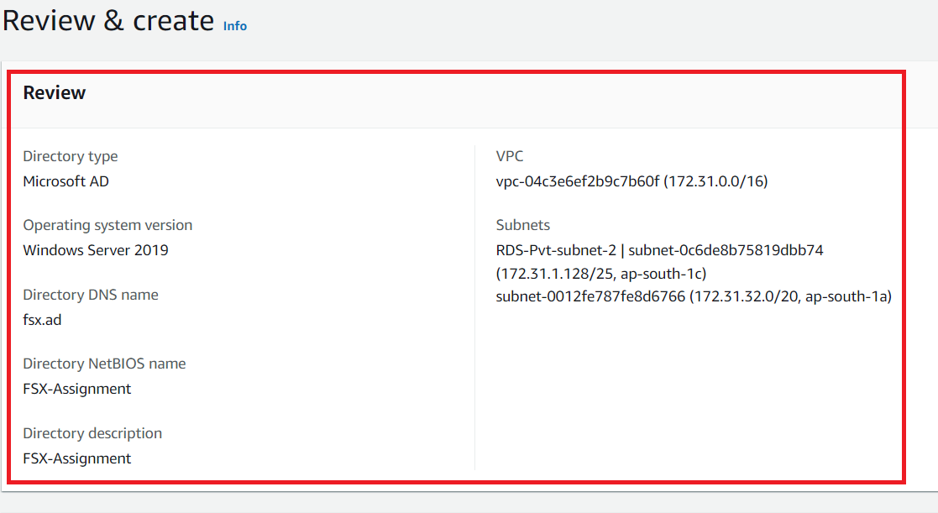

**Step 15: You** will also **get** the **“Pricing” details** inthe **“Review & create”** section**. Click** onthe **“Create directory”.**

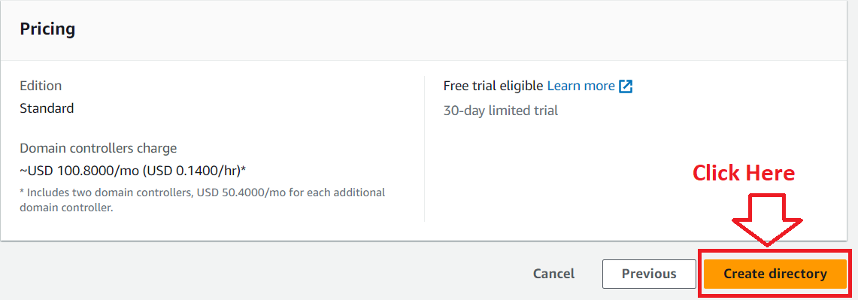

**Step 16: Your directory** will be **in** the **“Creating” status** after **clicking** on **“Create directory”.**

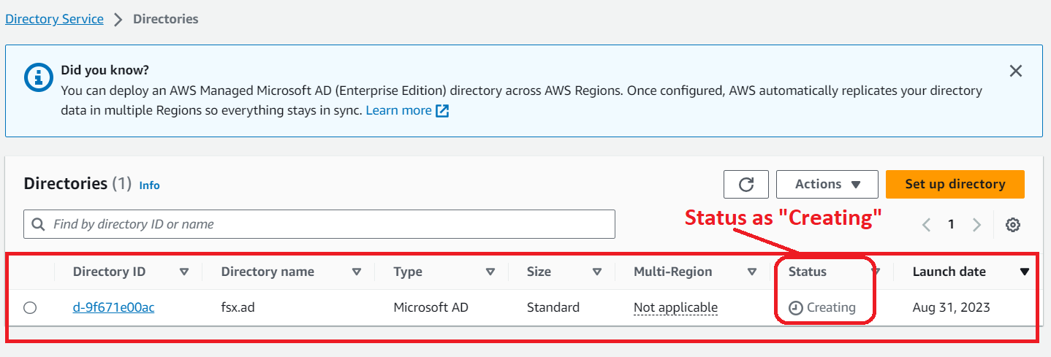

**Step 17: It** will be **taking approximately 30 Minutes** to be **go from** the **“Creating”** tothe **“Active” Status.**

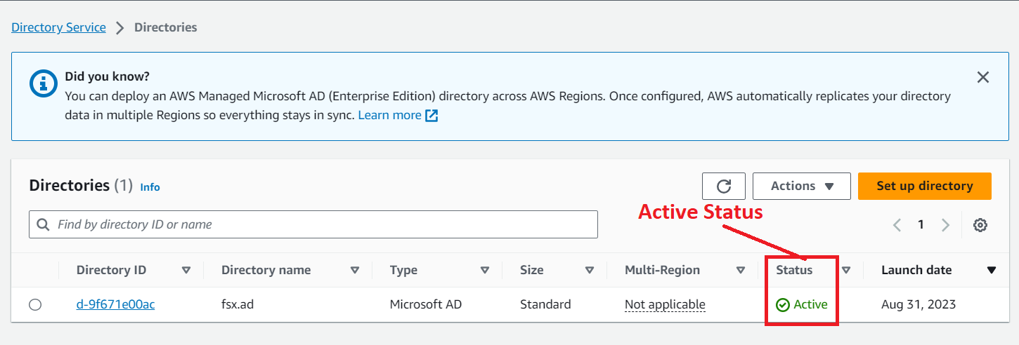

**Step 18: Now, go** tothe **“Windows Authentication”** inthe **“Create File System”** tab**. Choose** your **created directory (fsx.ad).**

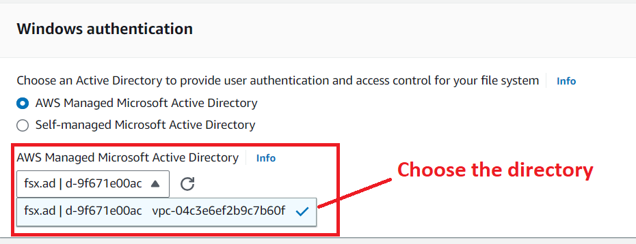

**Step 19: Leave** the **other settings** as it **is & click** onthe **“Next”.**

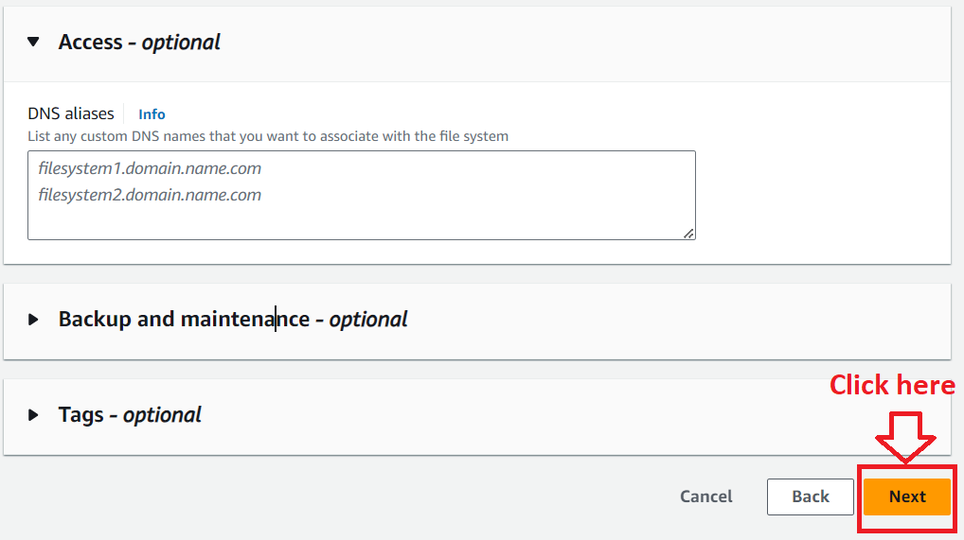

**Step 20: In** the **“Review and create”, you** will **view** the **“File System details”, which** are **editable** after the **creation or few are not editable.**

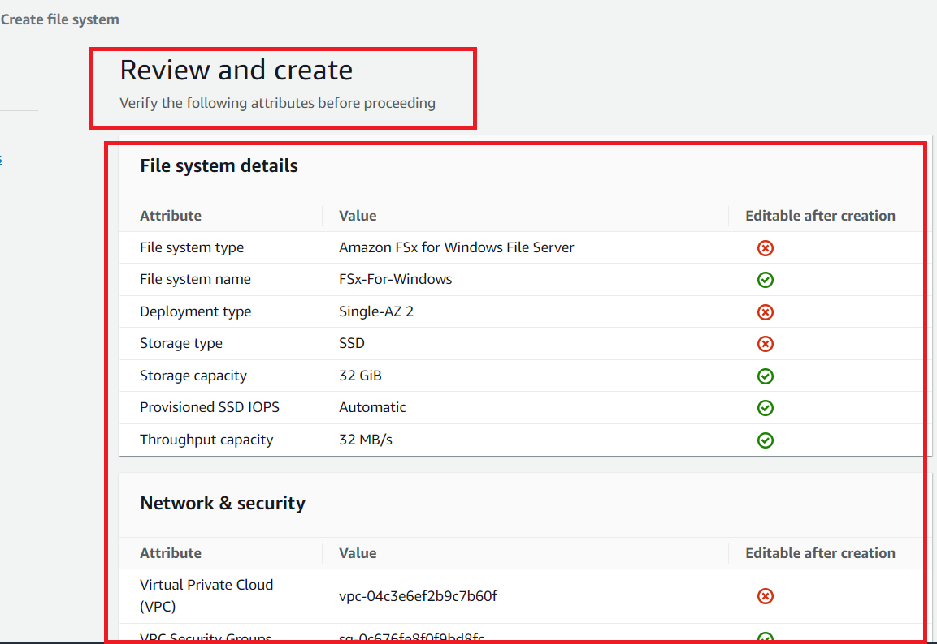

**Step 21: Click** onthe **“Create file system”.**

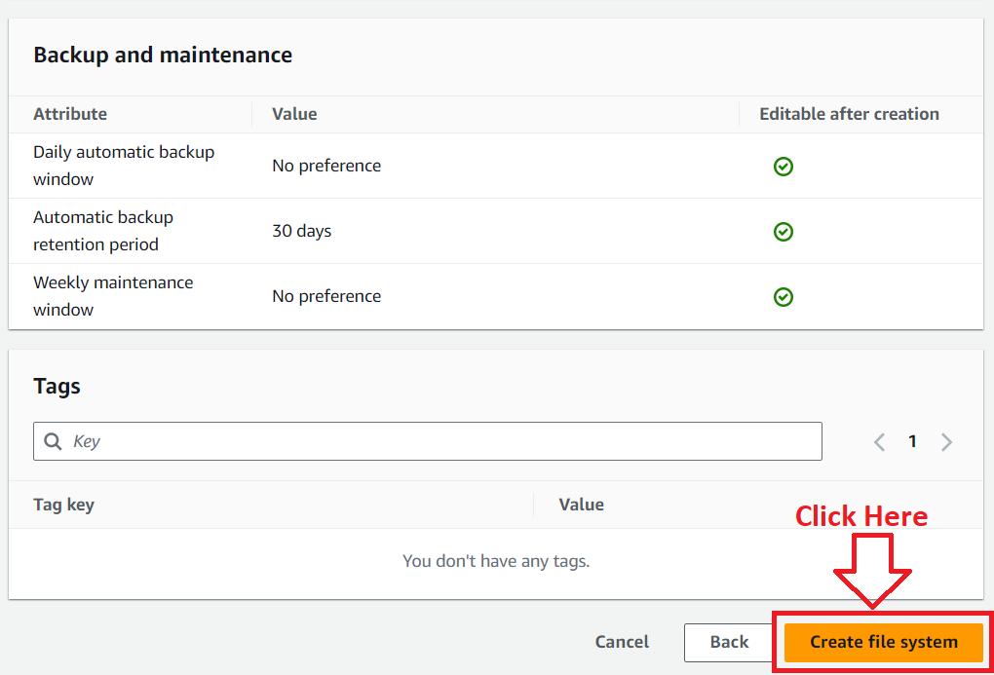

**Step 22: Now, your file system** has been **created** & **it** will **show** the **status** as **“Creating”.** **It** will **take approximately 30 minutes** to be **shown “Status”** as **“Available”.**

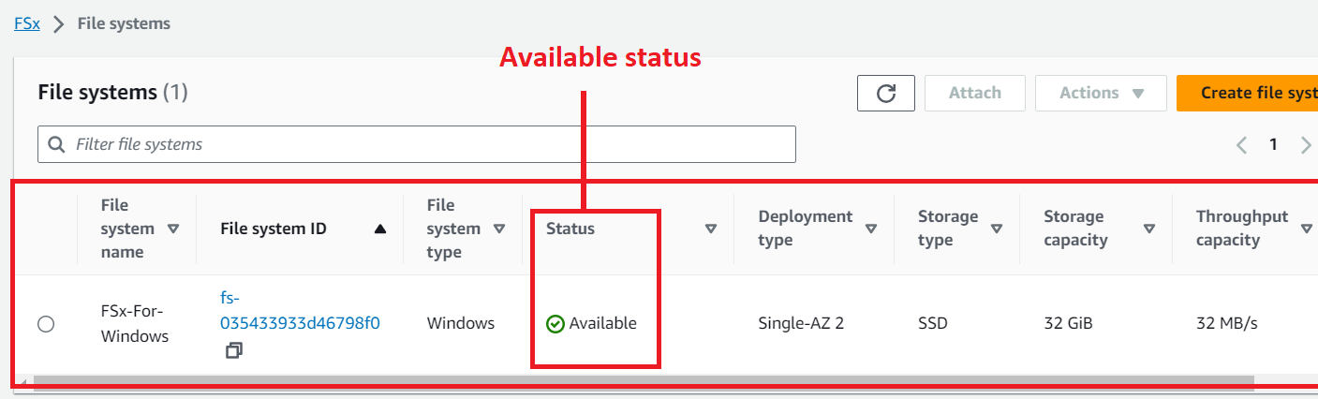

**Problem 1(b) Solution:** Connect it (FSx) to your Windows EC2 server.

**1. Create an EC2 Instance**

**Step 1: Go** tothe **“Services” section** & **search** the **“EC2” service** here. **Click** onthe **“Instances”.**

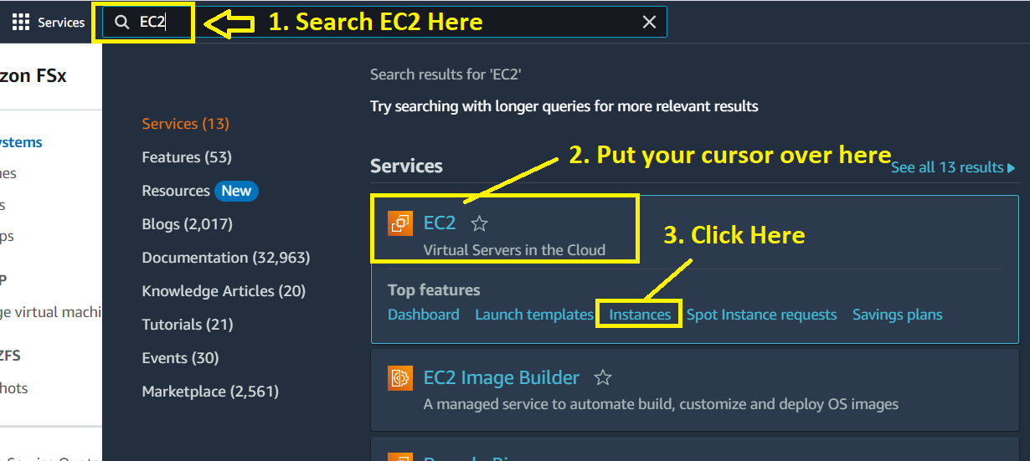

**Step 2: Click** onthe **“Launch Instances”.**

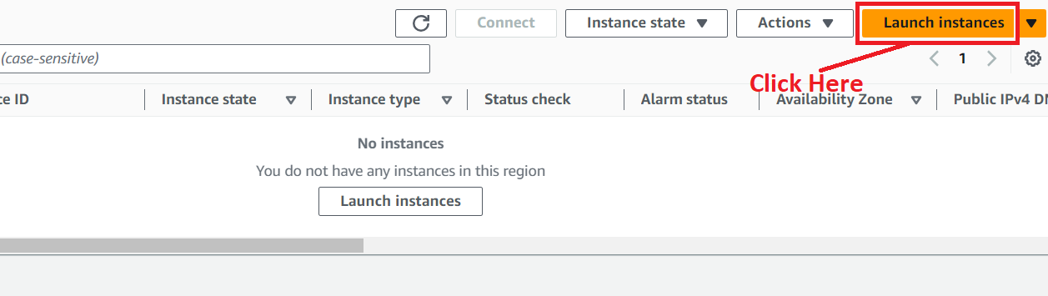

**Step 3: Choose** the **“Name”** asthe **“FSx-Connect”** inthe **“Name and tags”** section.

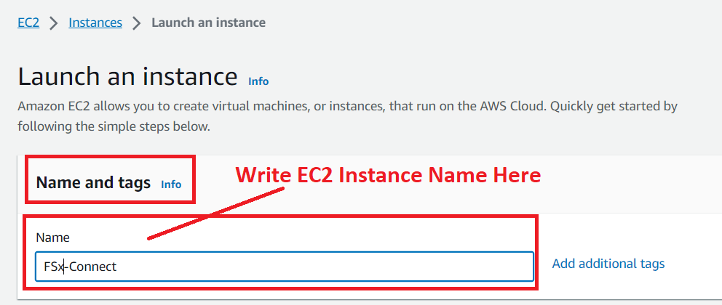

**Step 4: Choose** the **“Application and OS Image (Amazon Machine Image)”** asthe **“Windows”.**

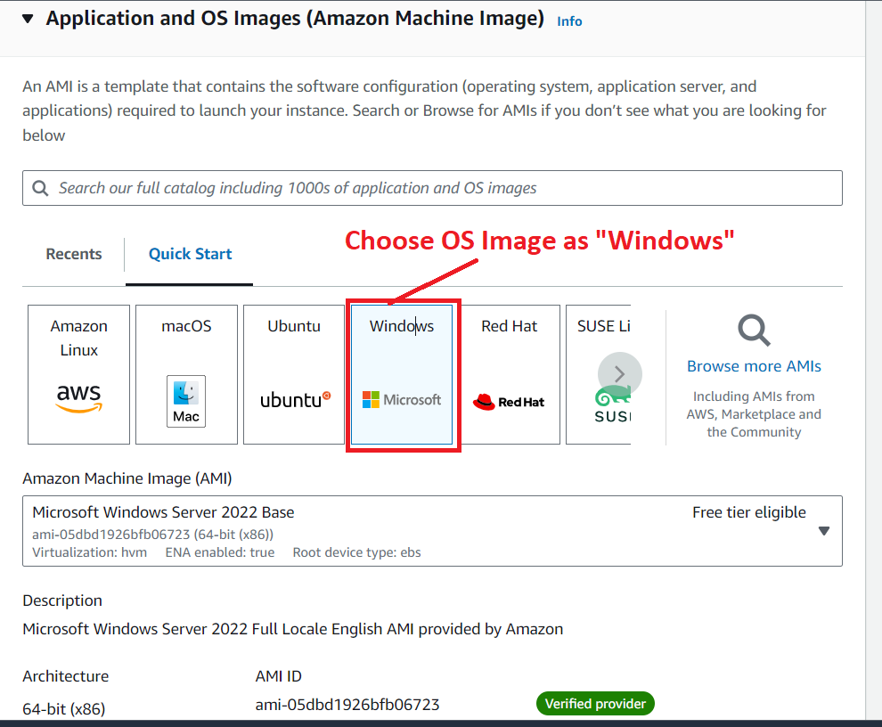

**Step 5: Remain** the **“Instance Type”** as **“t2.micro”.**

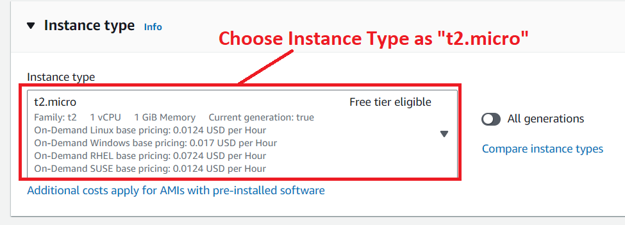

**Step 6: We will choose** the **“key pair name”** as **“MY-WEB-SERVER”.**

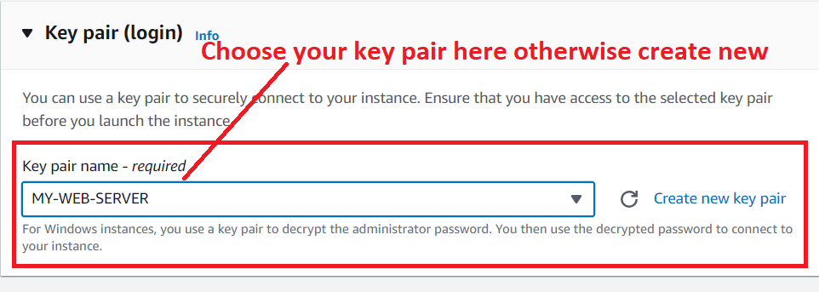

**Step 7: Remain** the **“Network settings”** such as **VPC & Subnet** by default, **no need** to **do any change here.**

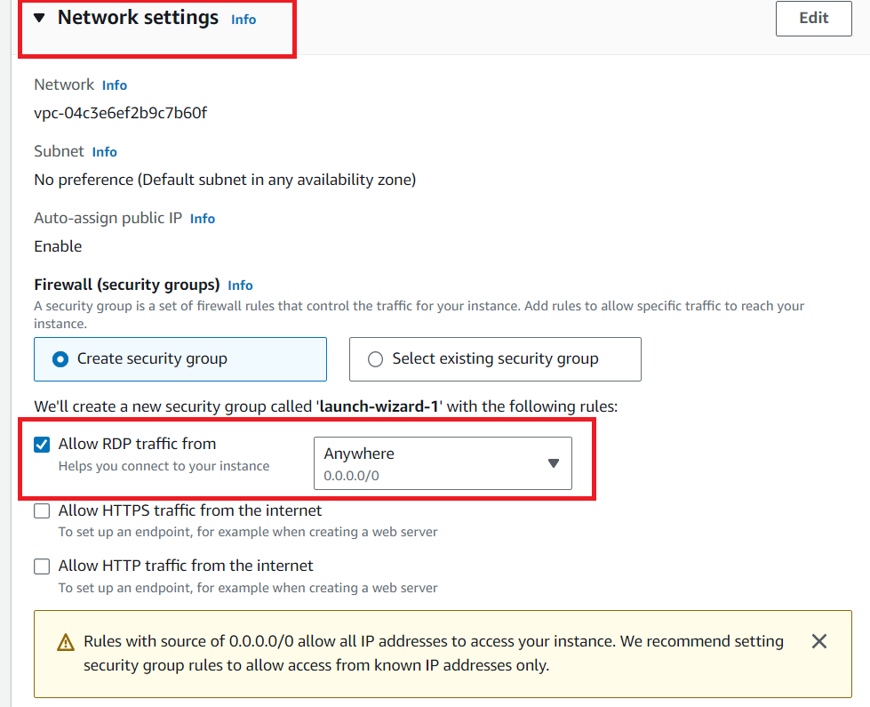

**Step 8: Click** onthe **“Edit”** in **“Network Settings”.**

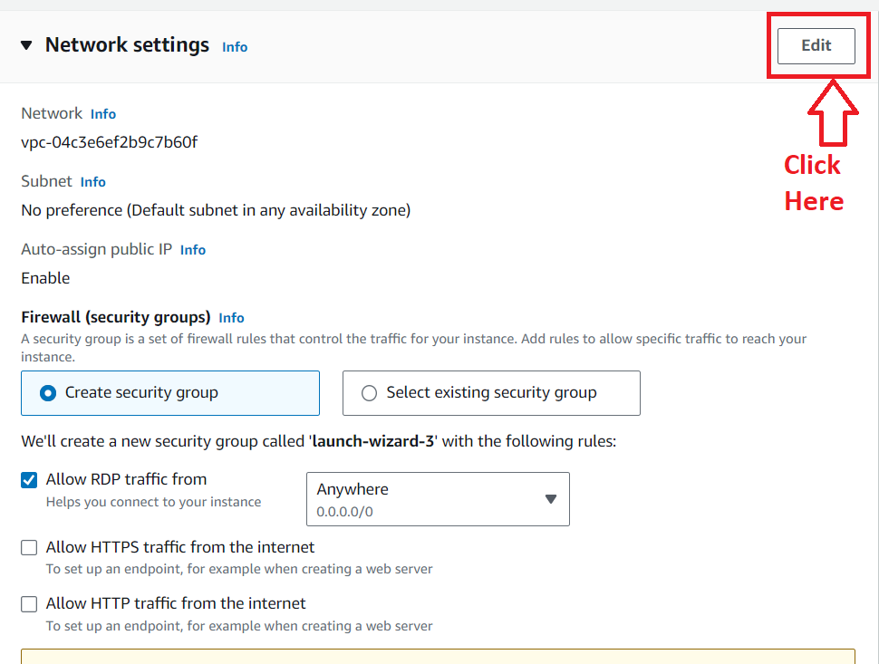

**Step 9: Click** on the **“Add security group rule”.**

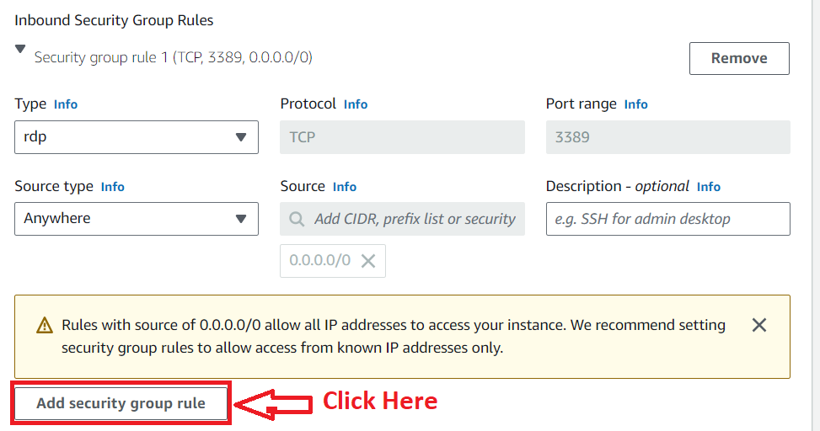

**Step 10: Choose** the **Type – “All Traffic” & Source type – “Anywhere”.**

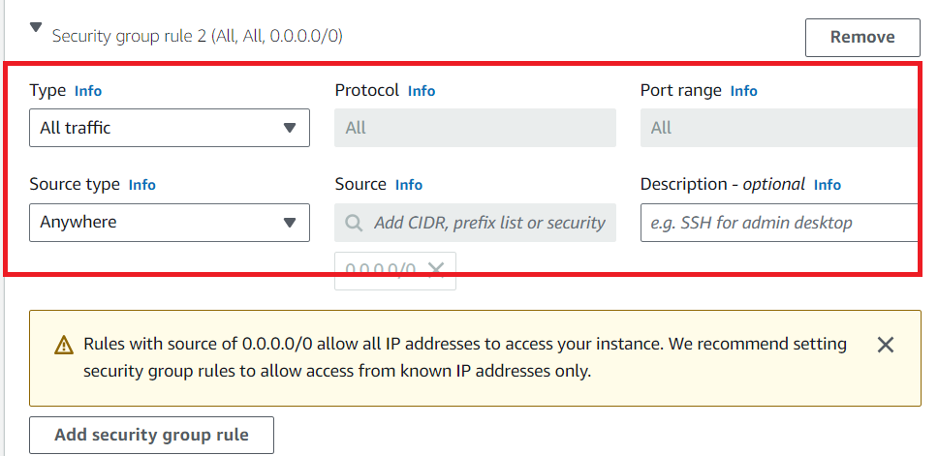

**Step 11: Click** onthe **“Launch Instance”.**

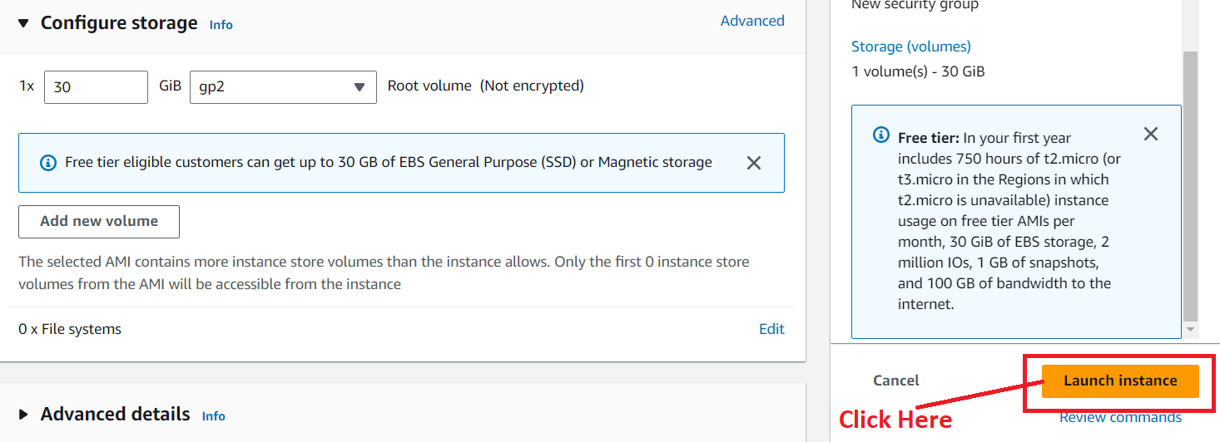**Step 12: Your instance** will be **successfully launched. Click** onthe **hyperlink (instance id).**

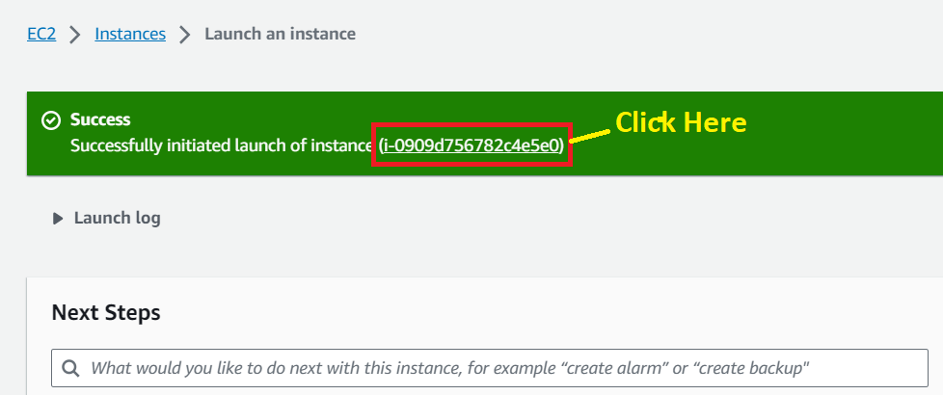

**Step 13: Your “instance state”** will be **shown** asthe **“Running”.**

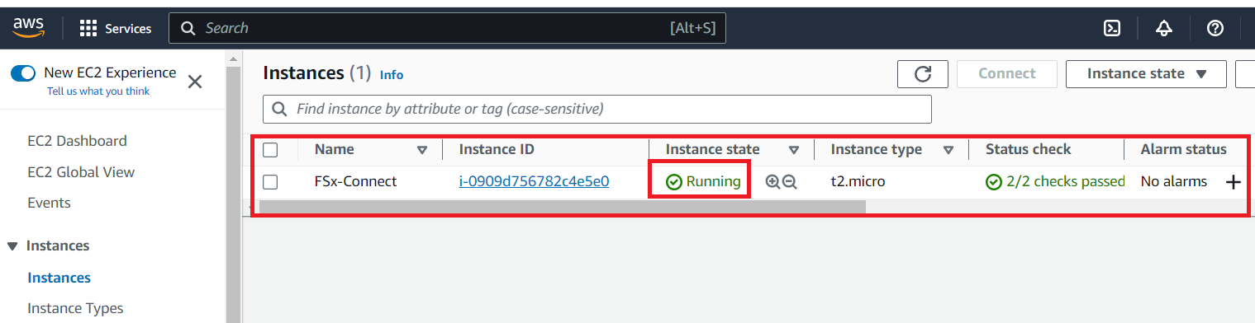

**2. Connect FSx to Windows through RDP Client**

**Step 1: Select** the **“Instance (FSx-Connect)”** & **click** onthe **“Connect”.**

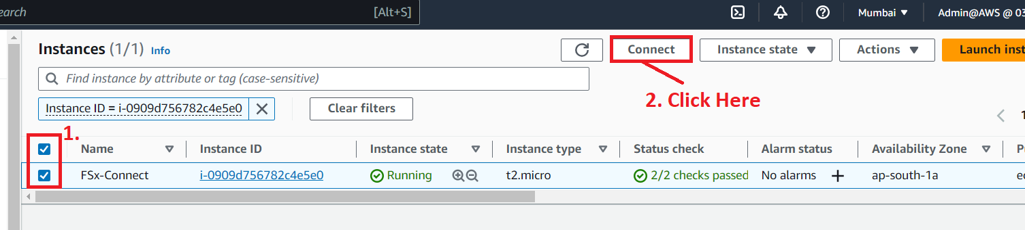

**Step 2: Go** tothe **“RDP Client”** & **click** onthe **“Download remote desktop file”.**

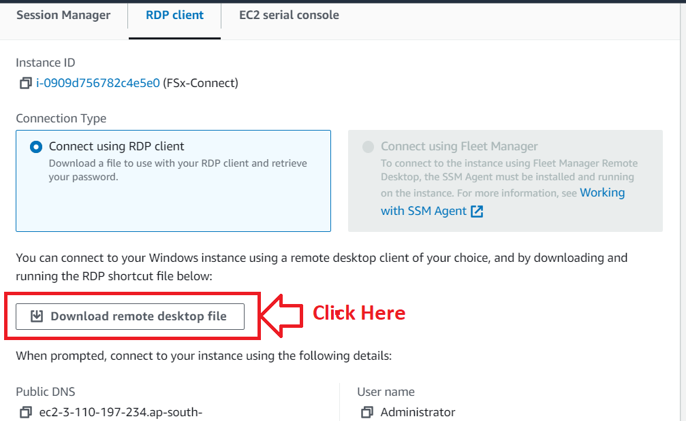

**Step 3: Your file** will be **downloaded. Click** on the **“FSx-Connect.rdp” here.**

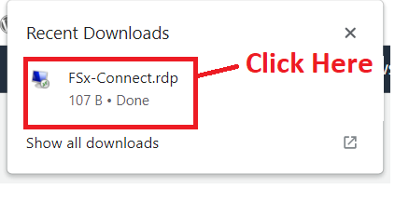

**Step 4: Click** on **the “Connect”.**

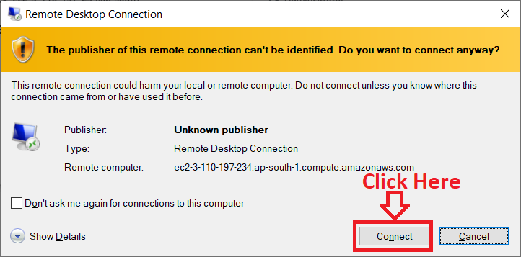

**Step 5: The window** ask youto **put** your **“Administrator Password”.**

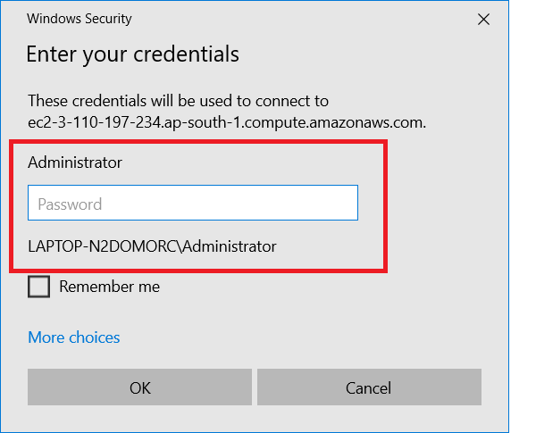

**Step 6: For getting** the **password, go** tothe **“Connect to instance”. Click** onthe **“Get password”.**

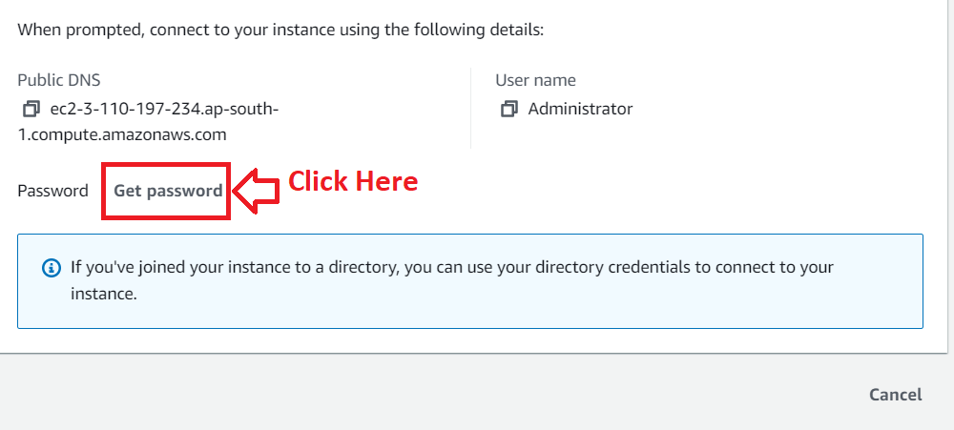

**Step 7: Click** on **“Upload private key file”.**

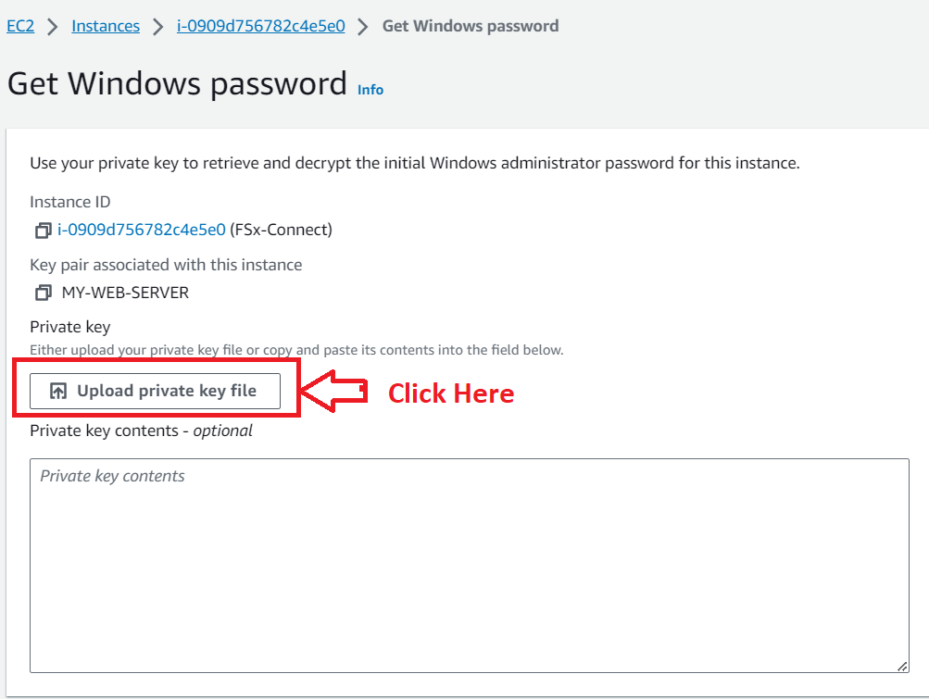

**Step 8: Upload** the **Selected (MY-WEB-SERVER.pem) file** here**, which you** have **chosen** as **“Key pair”.**

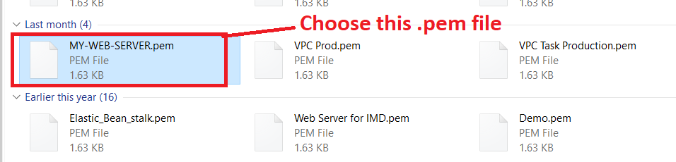

**Step 9: Click** onthe **“Open”.**

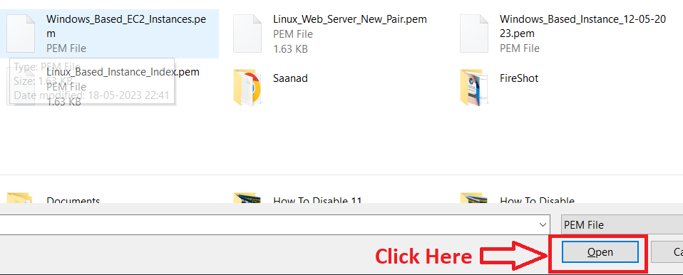

**Step 10: Click** onthe **“Decrypt Password”.**

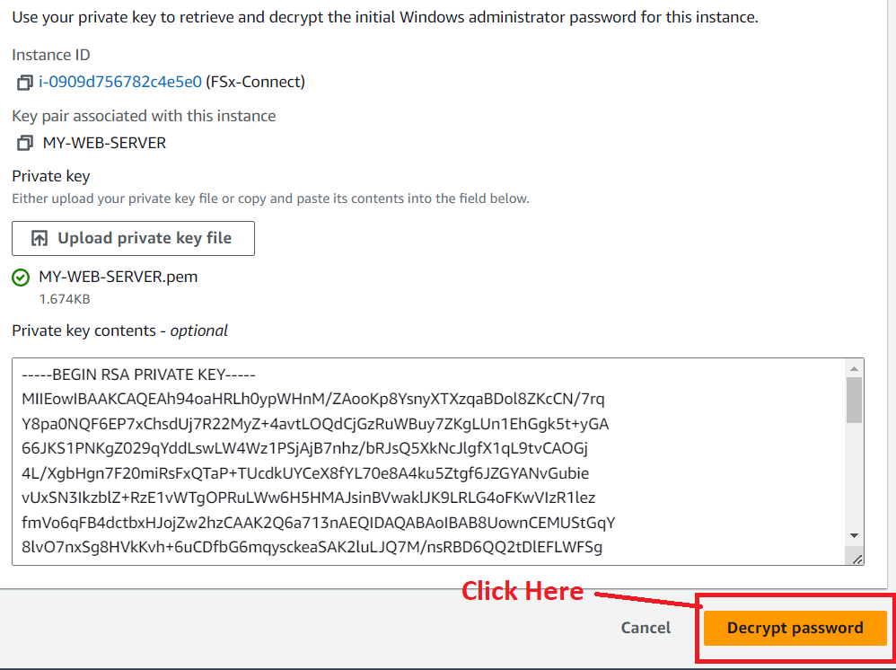

**Step 11: Copy** the **password** afterthe **“password decryption”.**

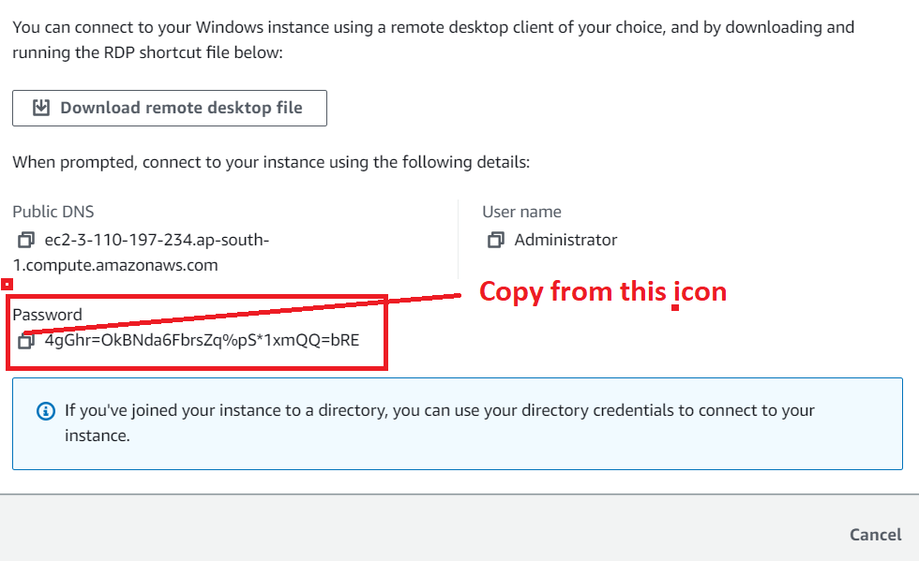

**Step 12: Go** to the **“RDP Client”** & **paste** the **password** there**. Click** onthe **“OK”.**

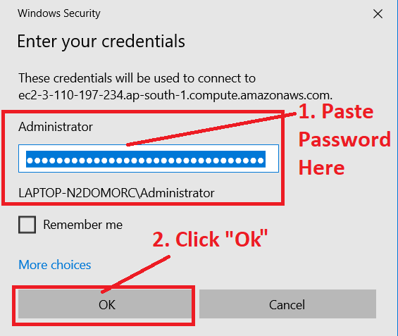

**Step 13: Click** on **“Yes”.**

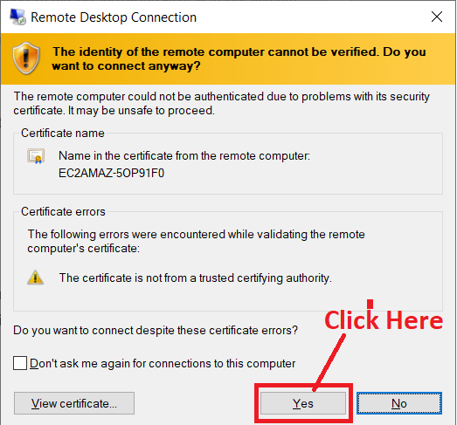

**Step 14: Your “Virtual Window”** will be **taken sometime** after **clicking** onthe **“Yes”. In** the **“Networks”, click** onthe **“Yes”** to **allow** the **internet access.**

**c**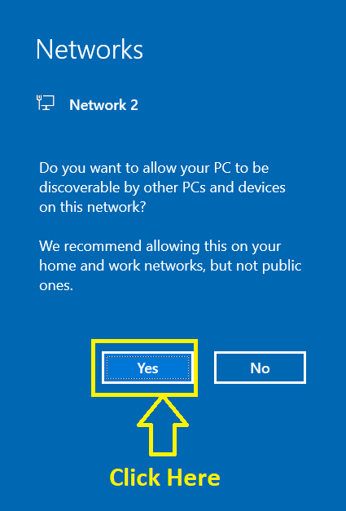

**Step 15: Your “Virtual Window Web Server”** is **ready** for **FSx connection.**

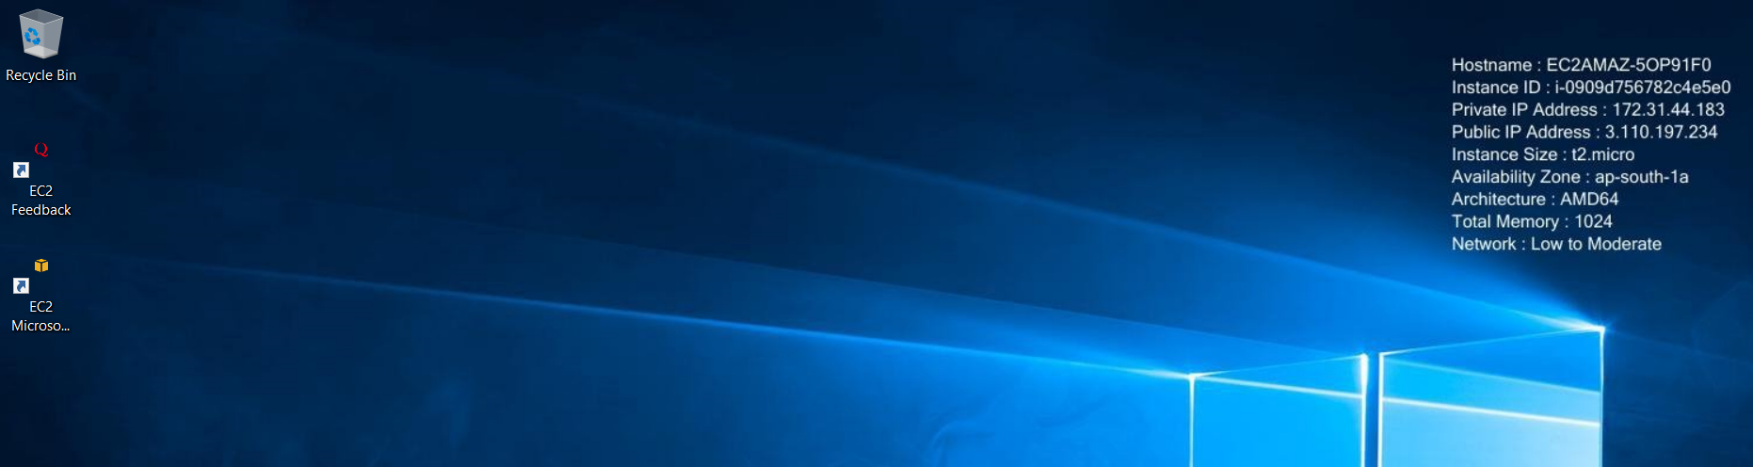

**Step 16: Search** the **“Control Panel”. Click** onthe **“Control Panel”.**

**c**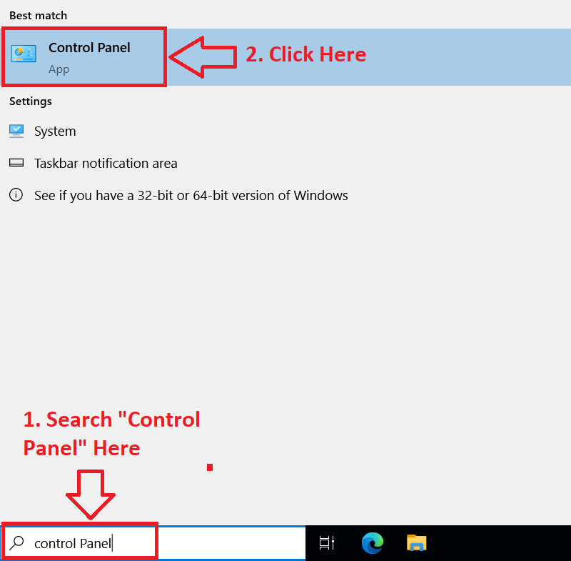

**Step 17: Click** onthe **“Network and Internet”.**

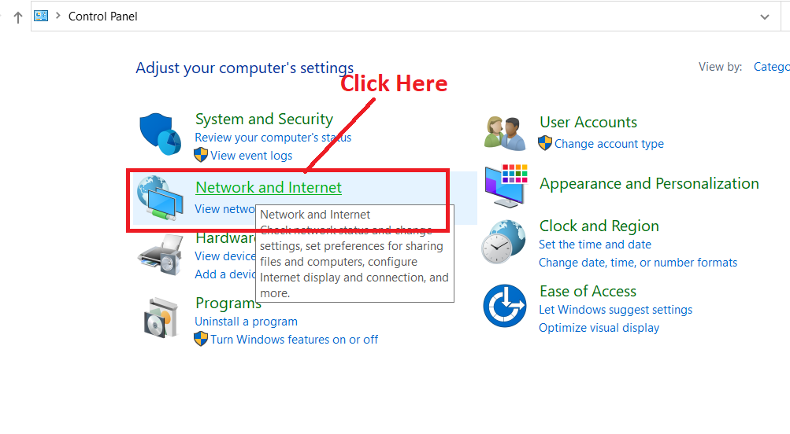

**Step 18: Click** on the **“Network and Sharing Center”.**

**c**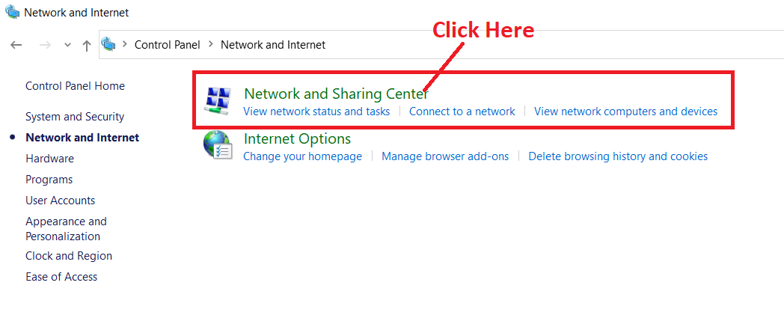

**Step 19: Click** onthe **“Change adapter settings”.**

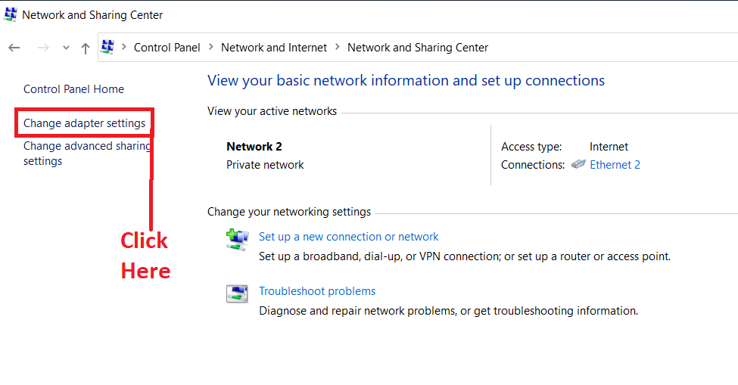

**Step 20: Select** the **“Ethernet2”.**

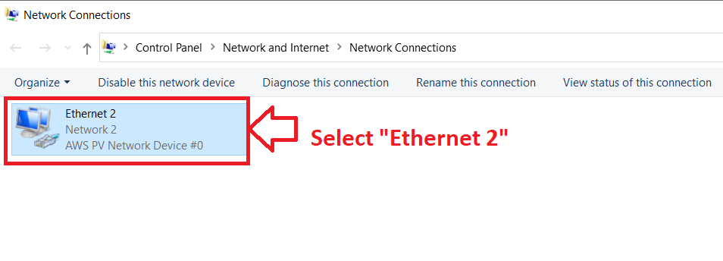

**Step 21: Do** the **right click** & **click** onthe **“Properties”.**

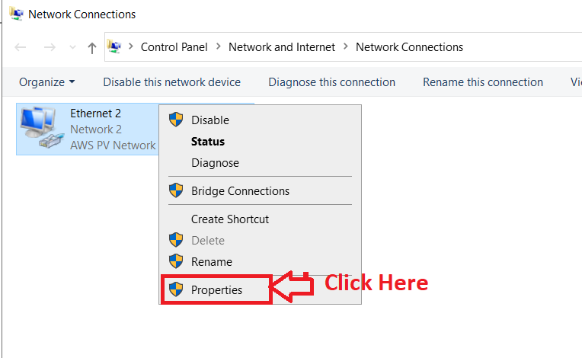

**Step 22: Choose** the **“Internet Protocol Version 4(TCP/IP)** & **go** to **its “Properties”.**

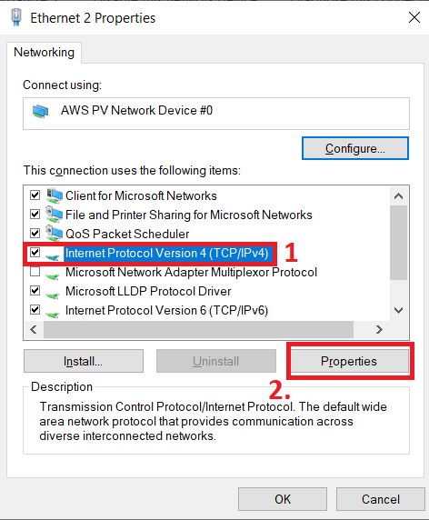

**Step 23:** The **“Internet Protocol Version 4 (TCP/IPV4) Properties tab”** will be **opened. In** the **“General” section,** remain the **“Obtain an IP address automatically”** as it is**.**

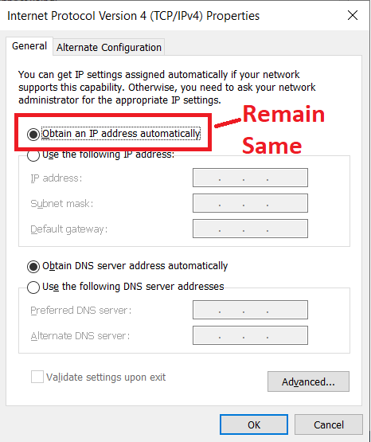

**Step 24: For pasting** the **“DNS server”** over here**, Go** tothe **“directory”** & **Copy both the “DNS addresses”** and **paste one by one** to the **“Windows DNS Server”** section**.**

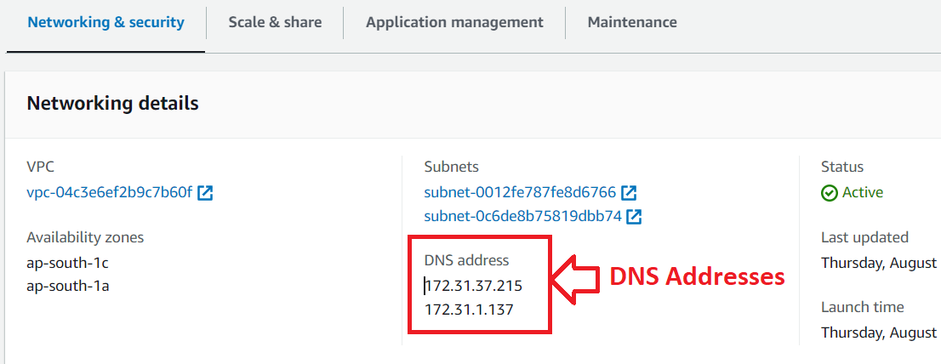

**Step 25: Paste** the **“DNS Addresses”** inthe **“Use the following DNS server addresses”. Click** on **“Ok”.**

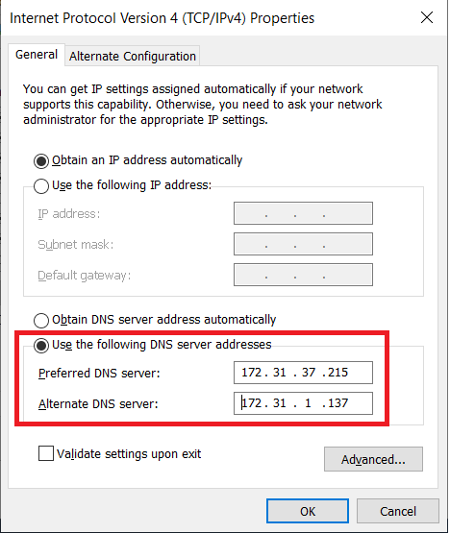

**Step 26: Click** onthe **“close”. Remove all** the **tabs after closing** this **tab.**

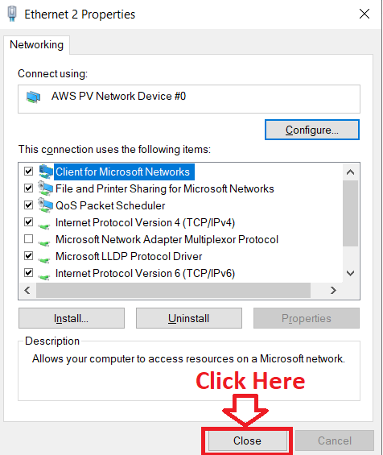

**Step 27: Again, go** tothe **“Control Panel”** & **click** onthe **“System and Security”.**

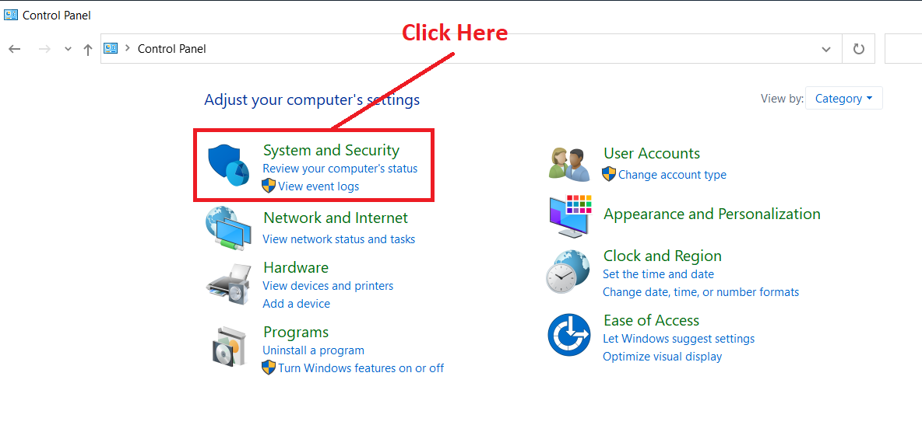

**Step 28: Go** to the **“System”.**

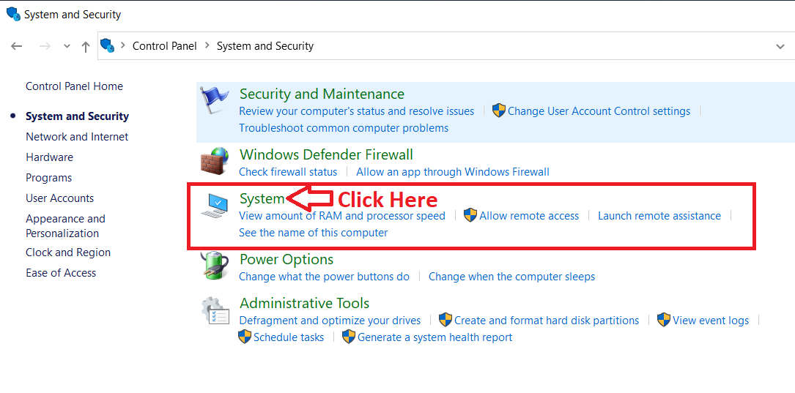

**Step 29: Go** to the **“Advanced System Settings”.**

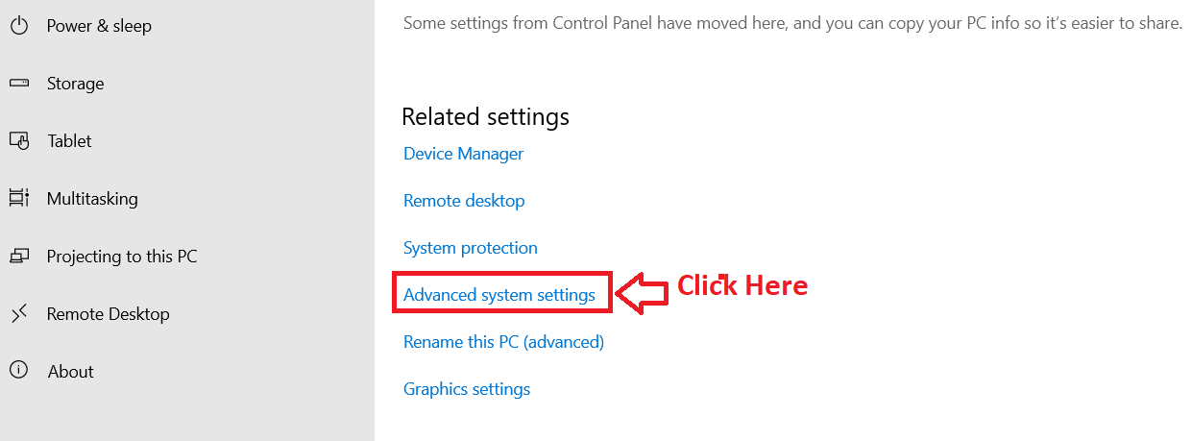

**Step 30: Go** tothe **“Computer Name”. Click** on the **“Change”.**

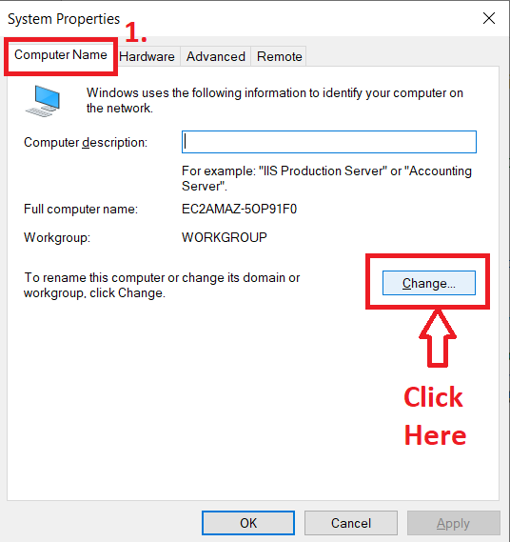

**Step 31: In** the **“Member of Domain”, put** your **“directory domain name” (fsx.ad)** over **here. Click** on the **“OK”.**

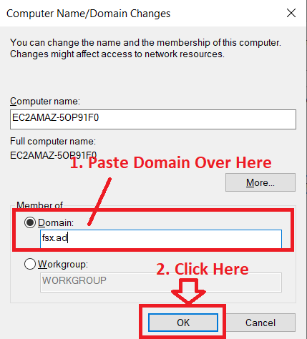

**Step 32: Put** the **“Admin & Password” over here** & **click** on the **“Ok”.**

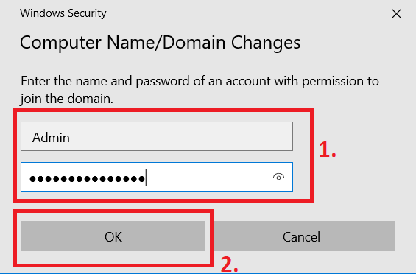

**Step 33: Click** onthe **“Ok”.**

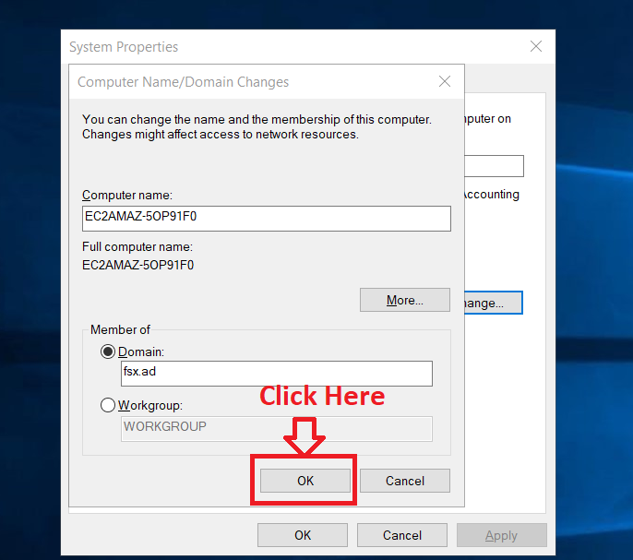

**Step 34: The “fsx.ad”** will be **successfully connected** to your **EC2 server. Click** onthe **“Ok”.**

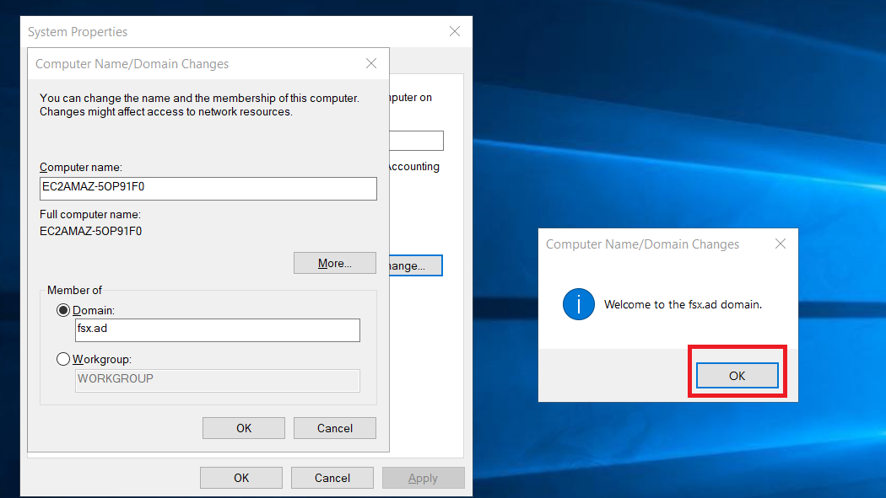

**Step 35: Now, click** on the **“Ok”** to **restart** the **machine** for **applying** the **changes.**

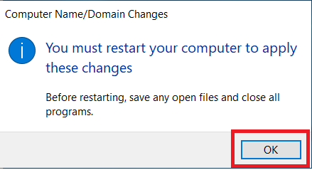

**Step 36: Click** on the **“Close”** in the **“System Properties”.**

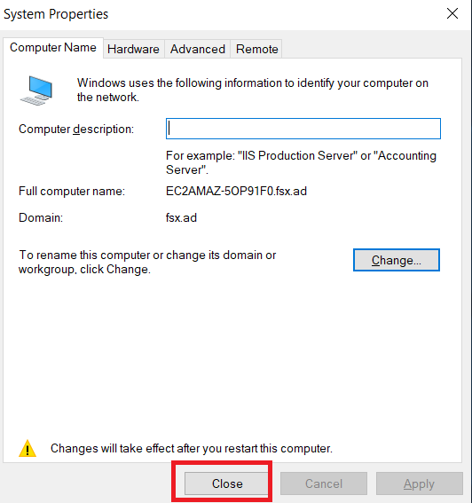

**Step 37: Click** onthe **“Restart Now”.**

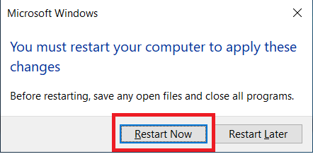

**Step 38: Now, again open** your **“RDP client” using** your **admin & password here. (Process** is **same** as **we mentioned** above **during** the **steps 4 to 13).**

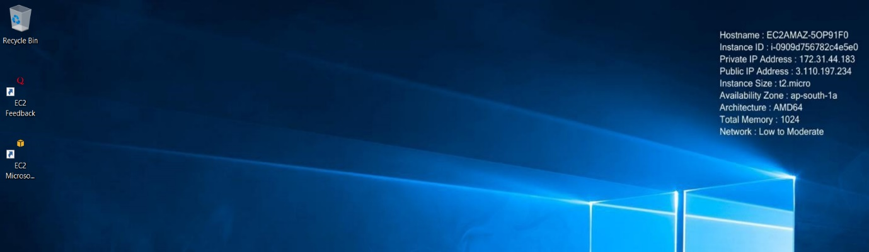

**Step 39:** Now, **go** to the “**FSx File System”**. Choose the “**File System Name (FSx-For-Windows)** & **click** on **“Attach”.**

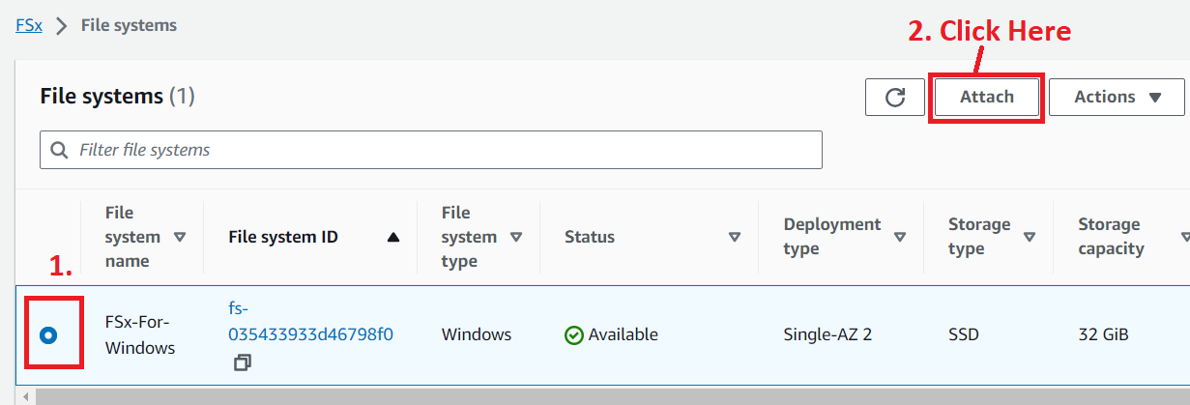

**Step 40: Copy** the **“highlighted command”.**

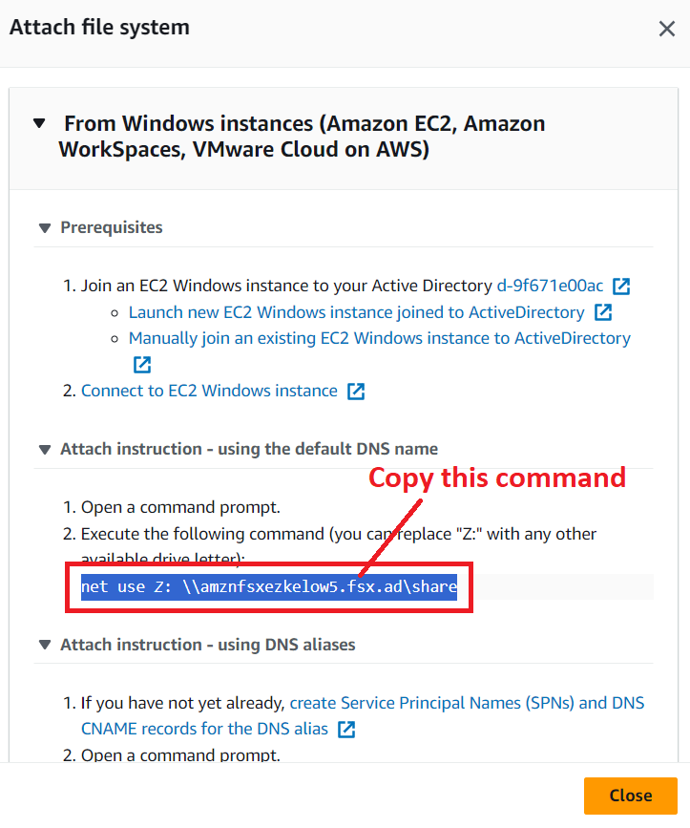

**Step 41: Go** to the **“RDP Client”** & **Open** the **“Command Prompt”.**

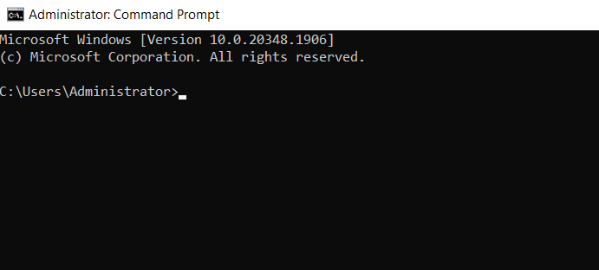

**Step 42: Paste** the **above-given command** over **here & press** the **“enter” button from** the **keyboard.**

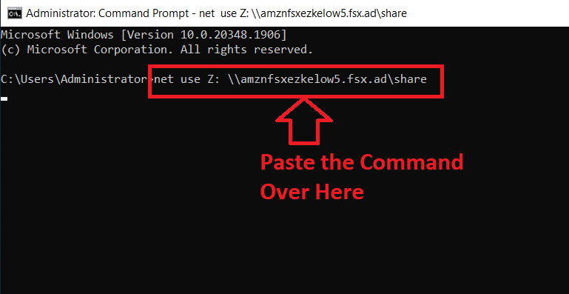

**Step 43: It** will **ask** you to **your username. Put** your **directory name** and **after that put** your **username like this: (fsx.ad\admin). Press “enter”** from the **keyboard.**

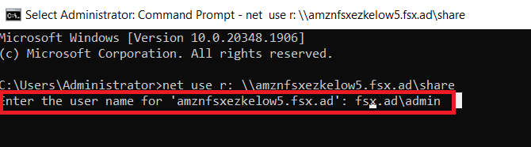

**Step 44: Now, type** the **password, which you** have **mentioned** during the **directory creation** & **press “enter”** fromthe **keyboard. But** the **password** will not be **visible.**

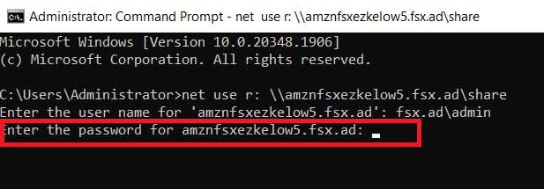

**Step 45: You** will **get** the **message “The command will be successfully completed”. This means, your “FSx directory”** will be **successfully connected** to the **“EC2 server”.**

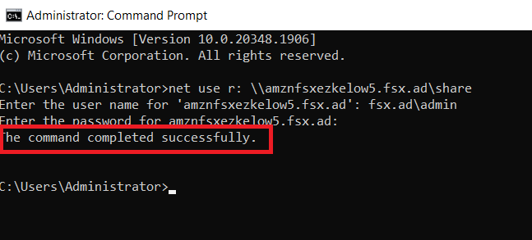

**Step 46: If you** want to **check** the **“r mount”, Click** on **the “File Explorer”.**

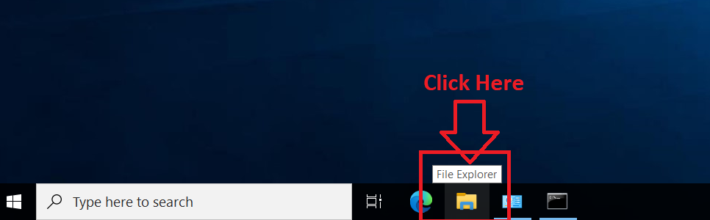

**Step 47: Go** to **“This PC”. You** can **view** your **“(R:)” mount** here **below** the **“C drive”.**

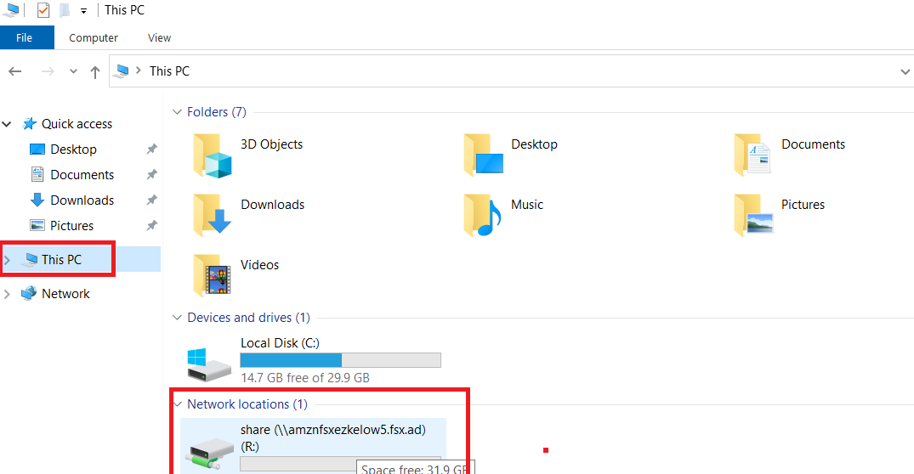

**Problem 2 Solution:** Create an FSx file system for Lustre and attach it to an Amazon Linux 2 instance.

**1. Create a Lustre File System**

**Step 1: Go** to the **“Services” section** & **search** the **“FSx”. Click** on the **“FSx”.**

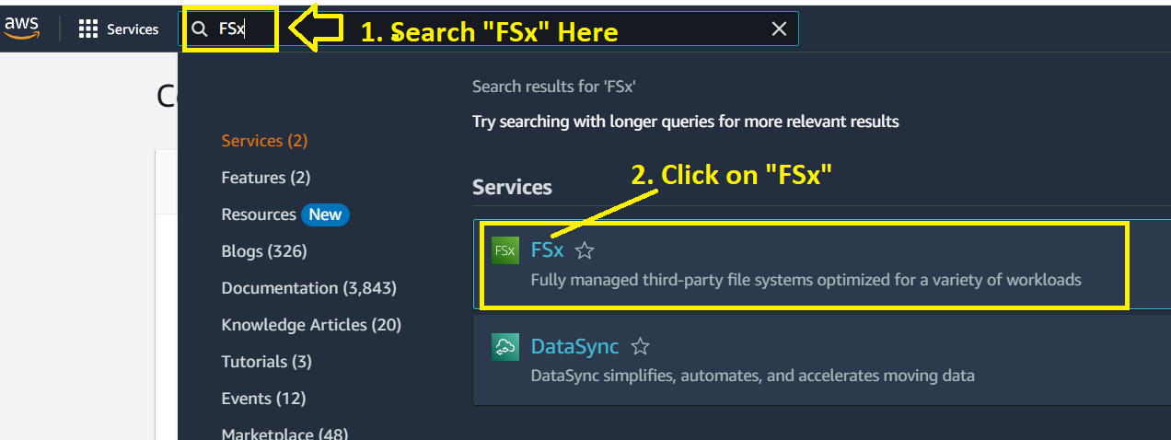

**Step 2: Click** onthe **“Create file systems”.**

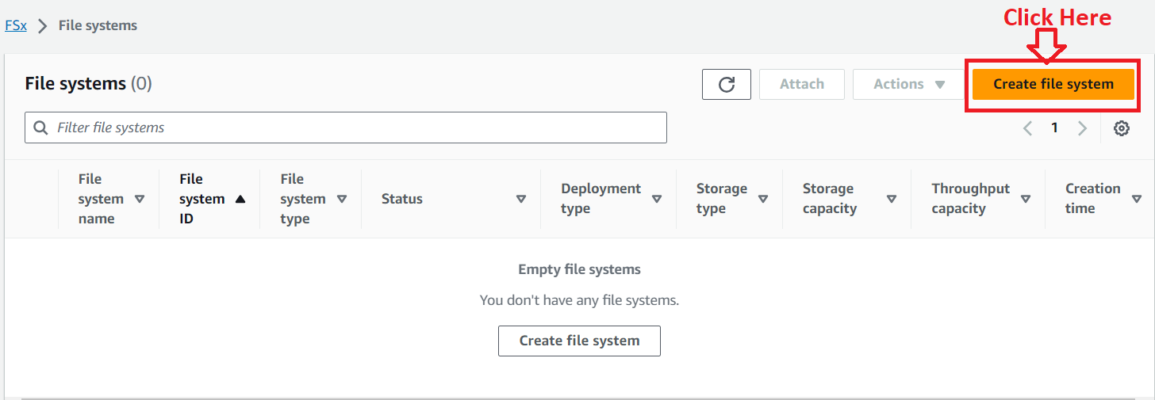

**Step 3: Choose** the **“Amazon FSx for Lustre”** in **“Select file system type”.**

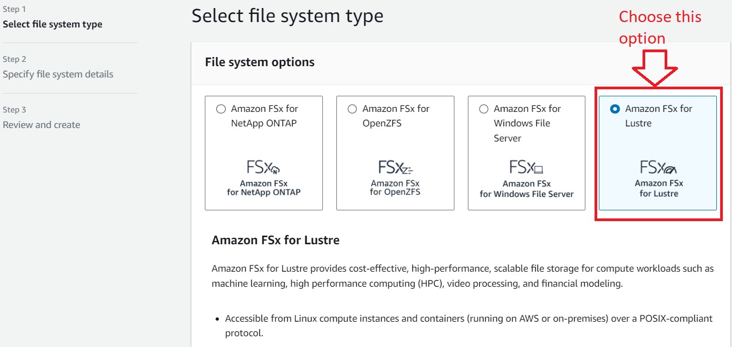

**Step 4: Click** on the **“Next”.**

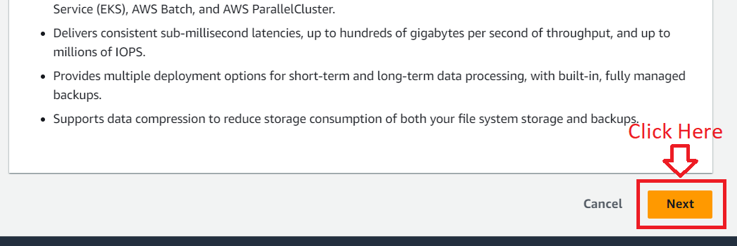

**Step 5: Choose** the **“File system name”** asthe **“FSx-For-Lustre” & select** the **“Deployment and storage type”** as **“Persistent, SSD”.**

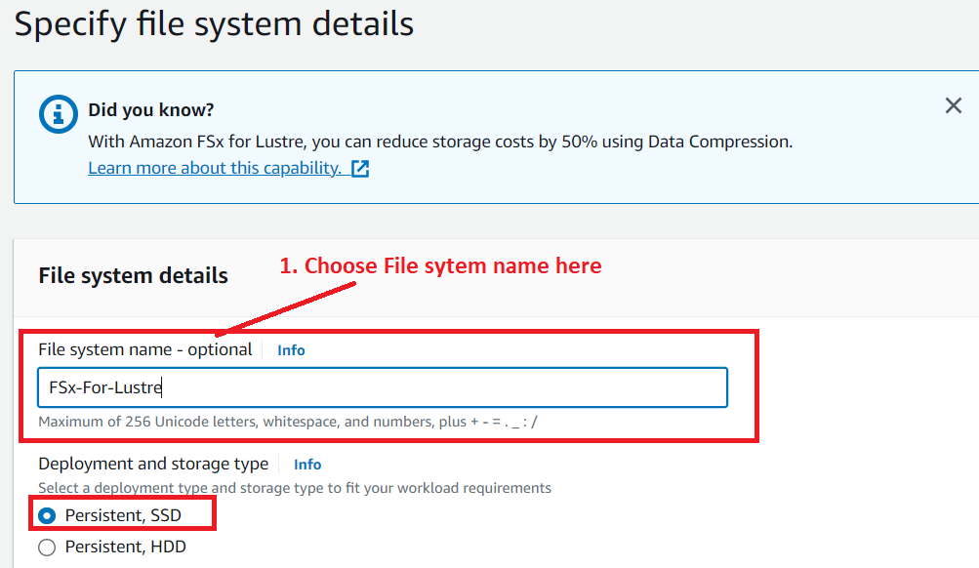

**Step 6: Choose** the **“Storage capacity”** as **“1.2 TiB”, which** is **minimum storage capacity. Remain** the **other settings** as it is **in “File System Details”.**

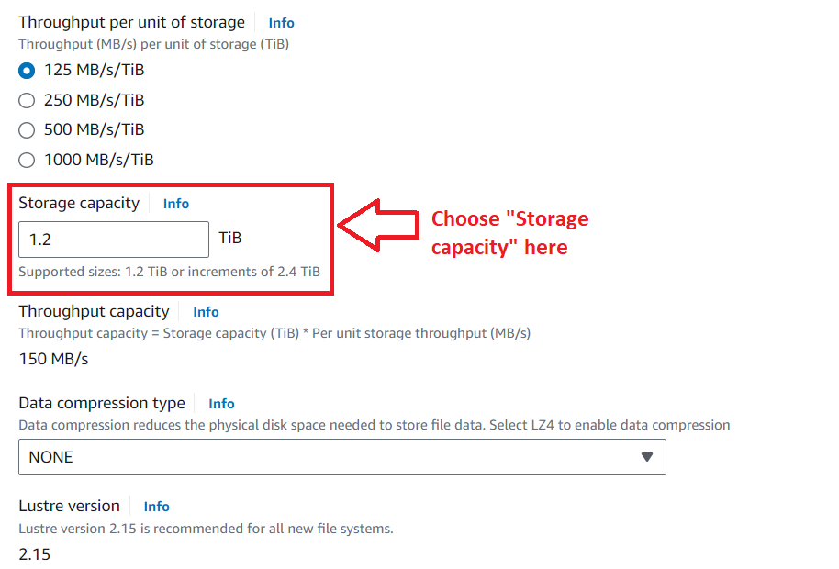

**Step 7: We** will **select** the **default VPC, security group** & **subnets** in the **“Network & security”.**

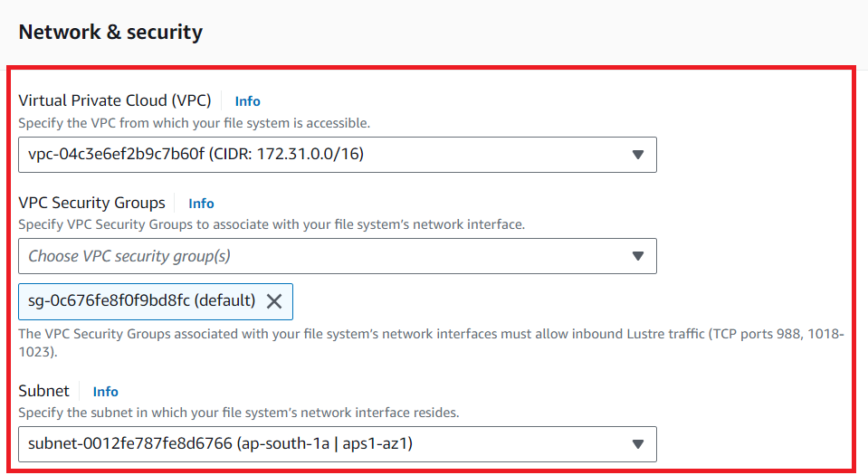

**Step 8: Leave** the **other settings** as **it is & click** onthe **“Next”.**

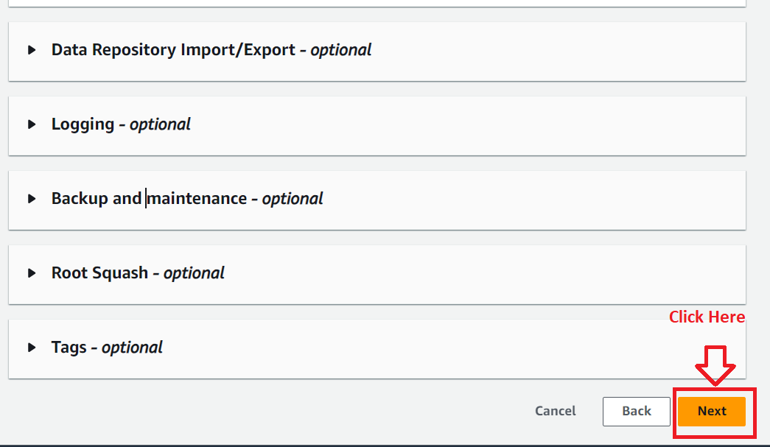

**Step 9: In “Review and create”, click on “Create file system”.**

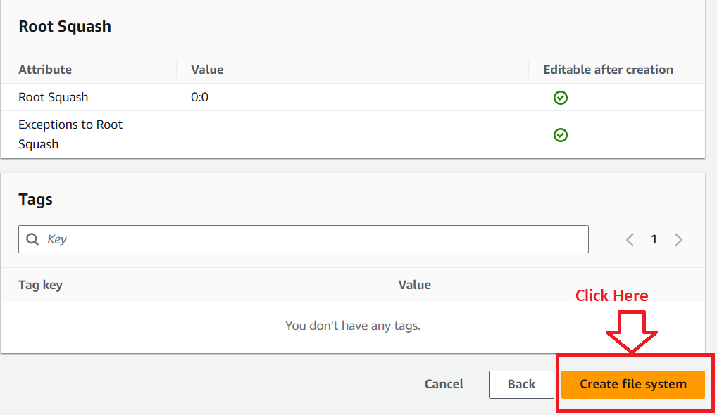

**Step 10: The “Amazon FSx for Lustre” file system** will be **started creating.**

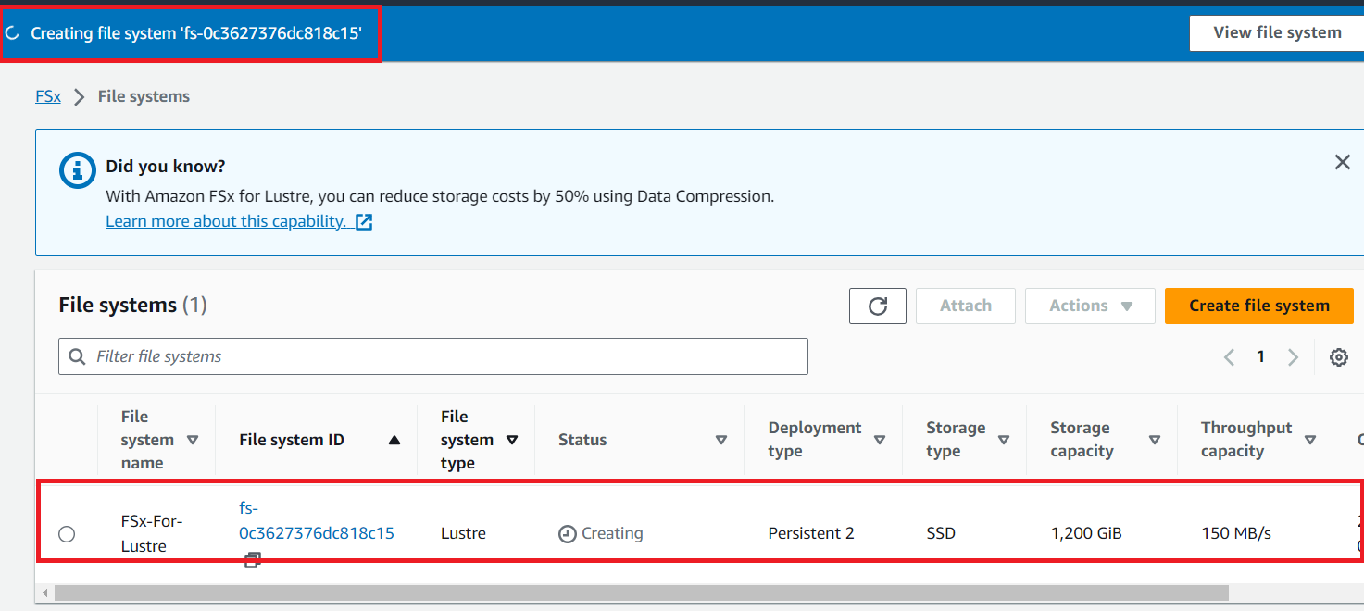

**Step 11: After** the **“10 minutes”, your FSx-For-Lustre file system** will go **to “Available” State** from **“Creating” state.**

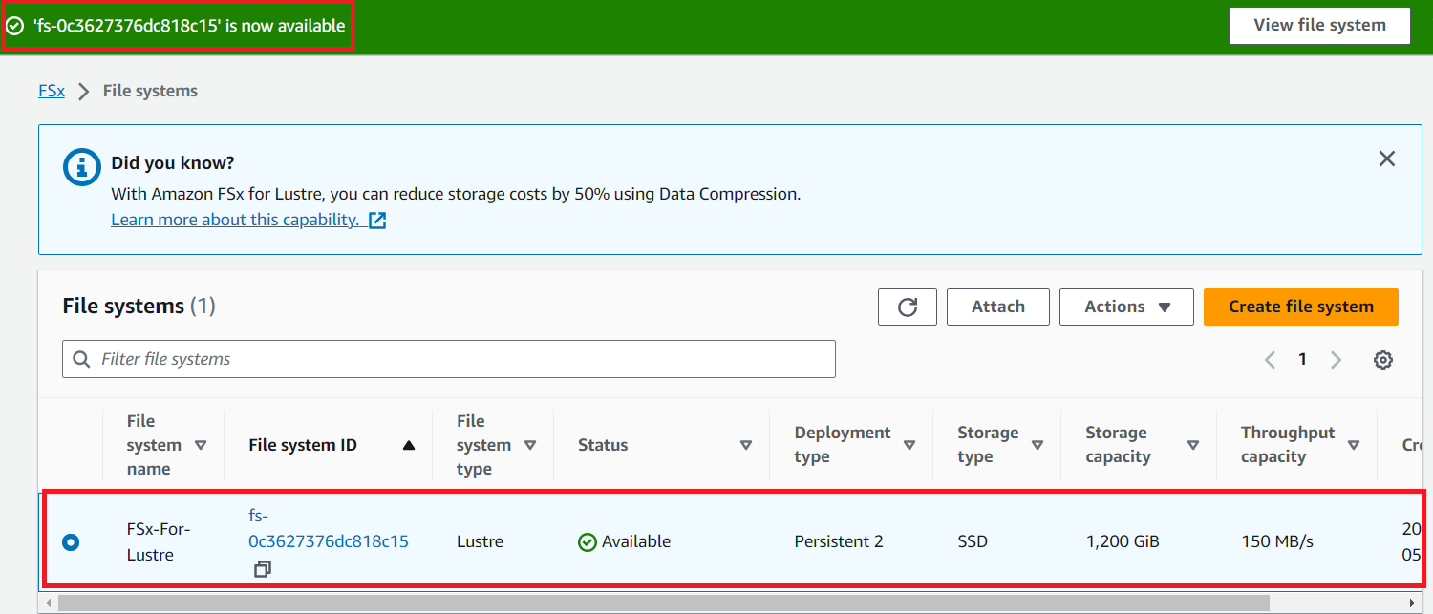

**2. Edit Your Security Group Rules**

**Step 1: Click** onthe **“File System Id”.**

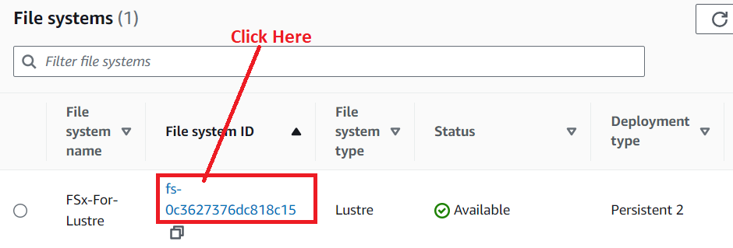

**Step 2: Go** tothe **“Subnet”** & **click** on **Network Interface Id (eni-018d3323ce2bdab73).**

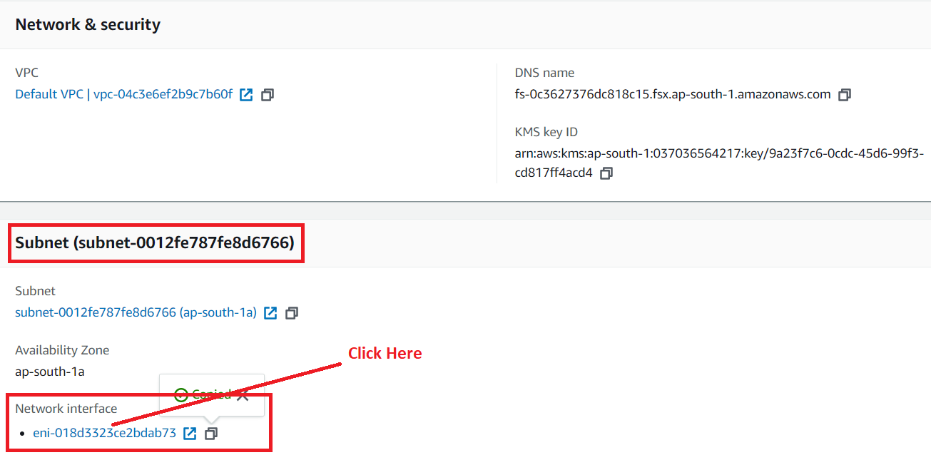

**Step 3: Again, click** onthe **“Network Interface Id”.**

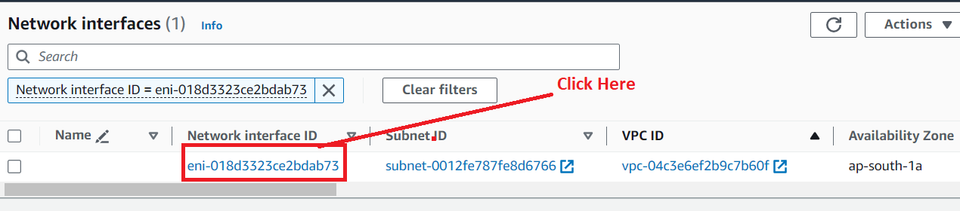

**Step 4: Click** onthe **“Security Group”.**

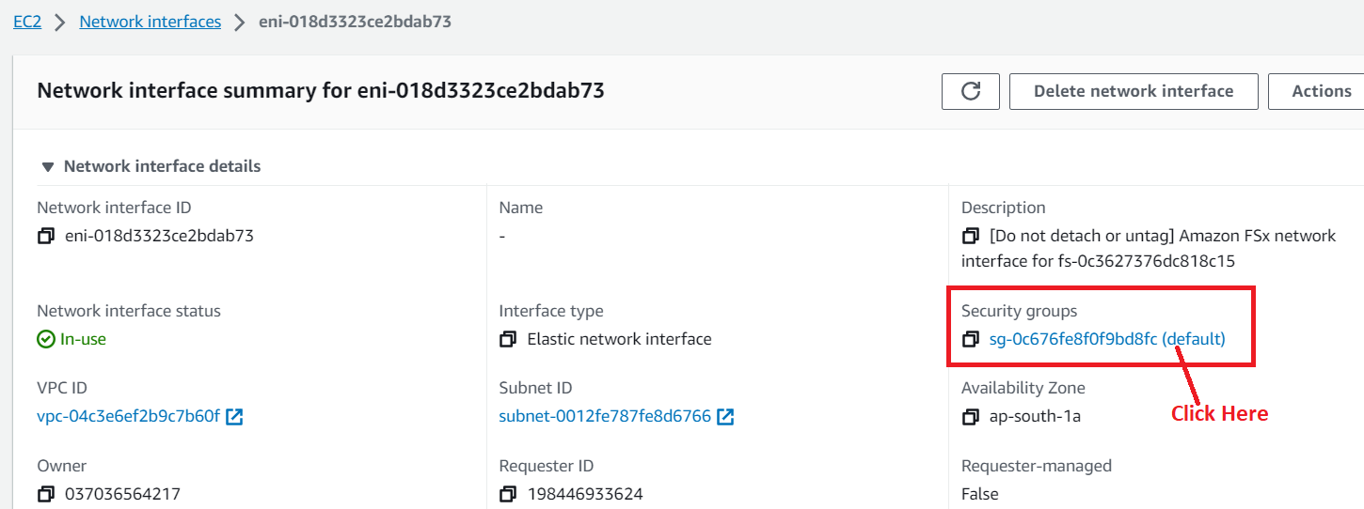

**Step 5: Click** onthe **“Edit Inbound Rules”.**

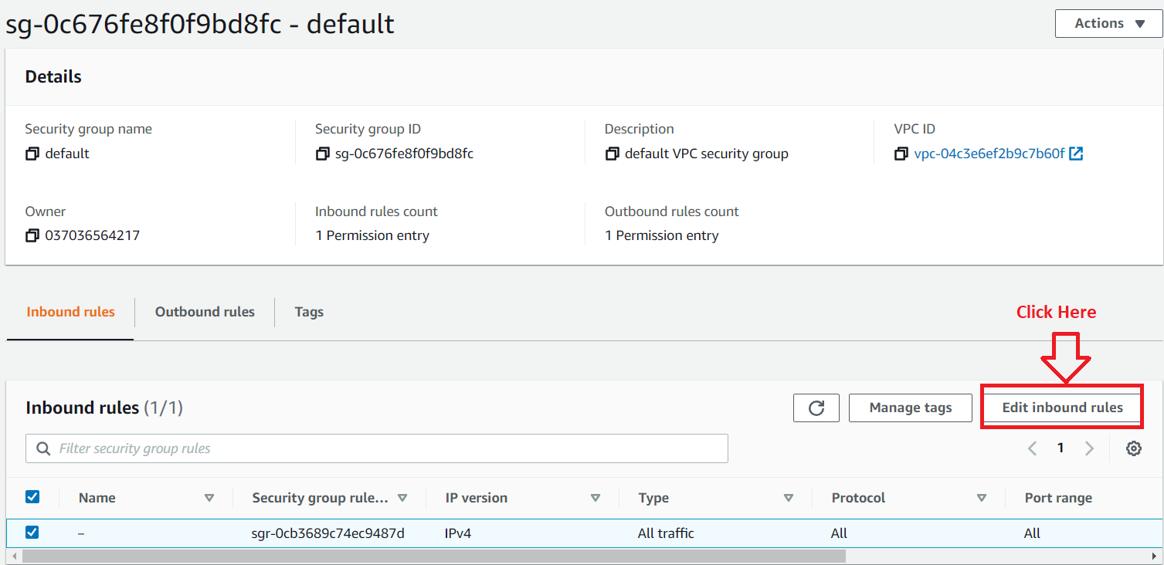

**Step 6: Click** on the **“Add Rule”.**

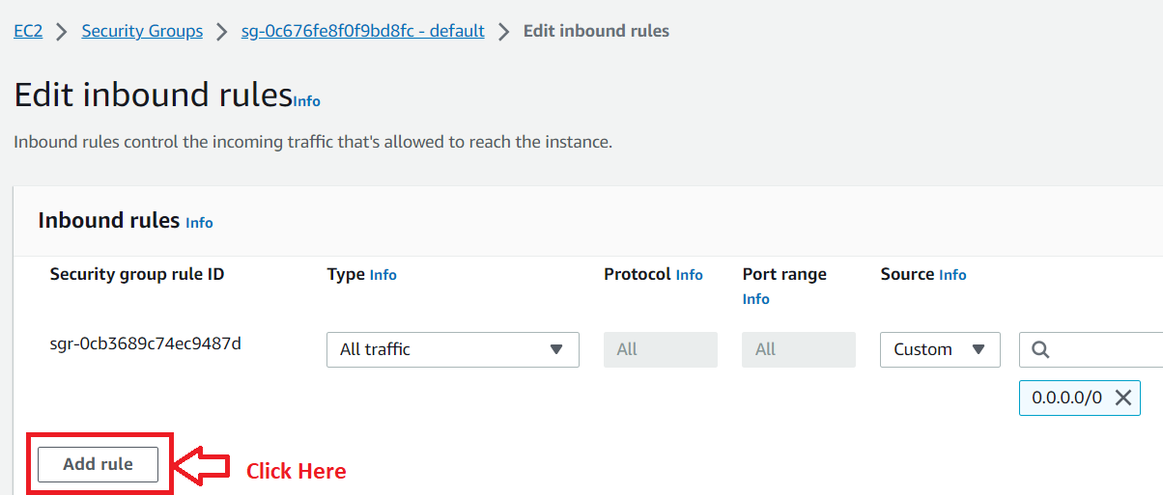

**Step 7: Choose the “TCP Port”** as **“988”** & **source** as **“Anywhere”. Again, click** onthe **“Add rule”.**

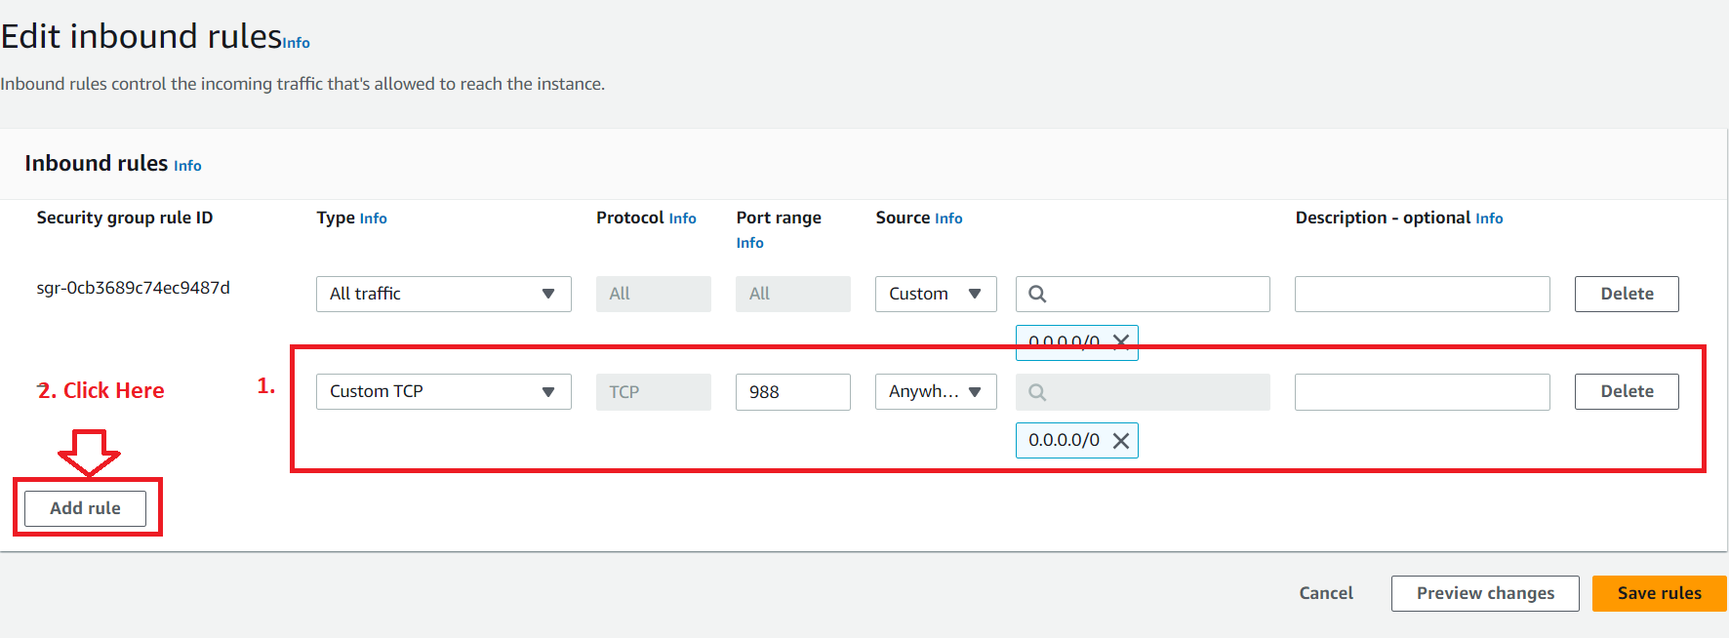

**Step 8: Choose** the **“TCP Port”** as **“1018-1023”** & **Source** as **“Anywhere”. Click** on **“Save rules”.**

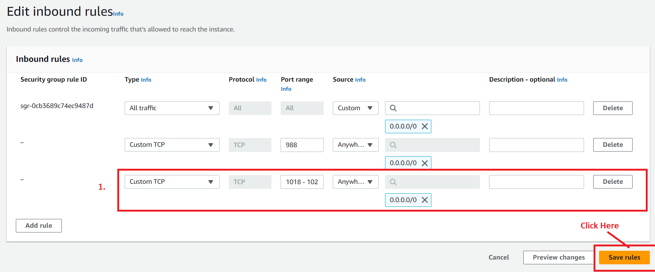

**Step 9: Your inbound rule** will be **successfully added.**

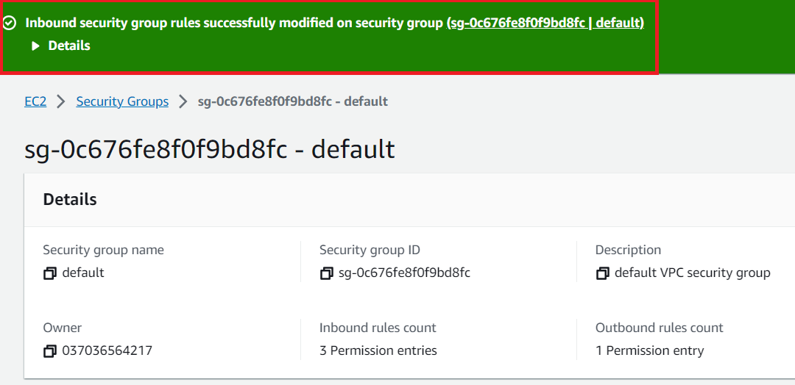

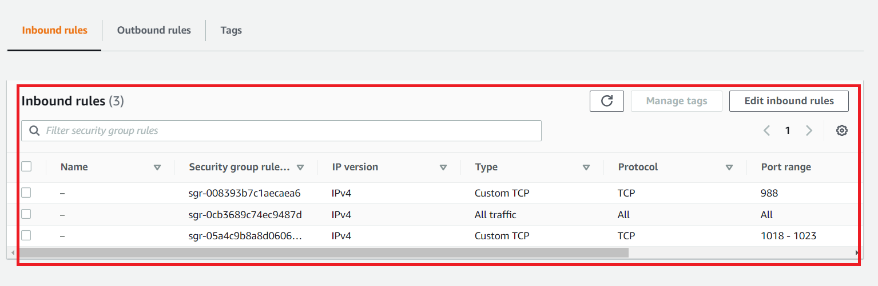

**3. Create an EC2 Instance**

**Step 1: Go** to **Services section** & **search “EC2”. Click** on **“Instances”.**



**Step 2: Click** on **“Launch Instance”.**

**Step 3: Choose** the **“Name”** asthe **“FSx-for-EC2”** inthe **“Name and tags”** section.

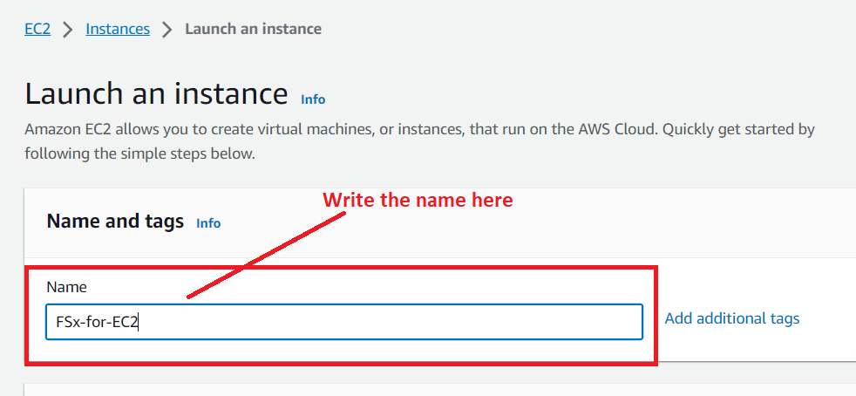

**Step 4: Choose** the **“AMI”** as **“Amazon Linux 2.**

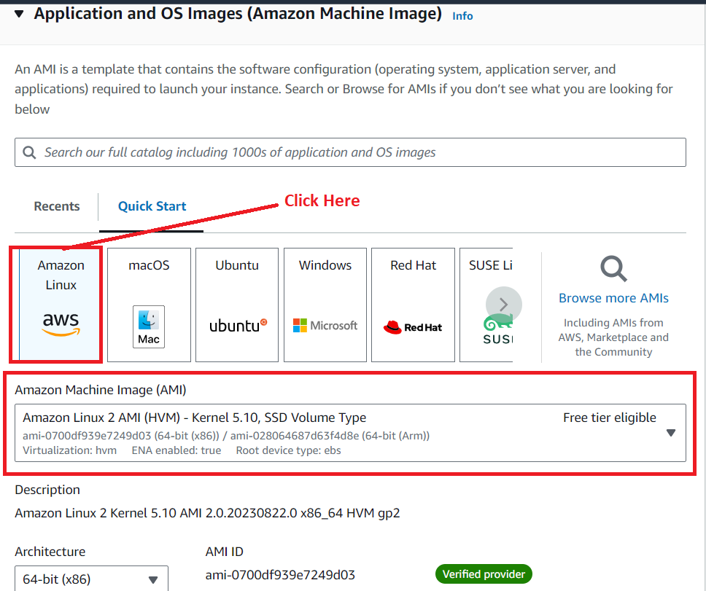

**Step 5: Choose** the **“Instance type”** as **“t2.micro”.**

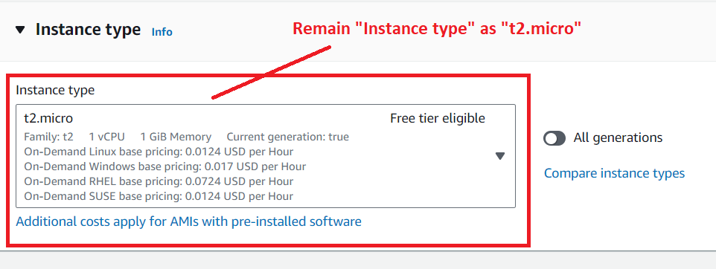

**Step 6: Choose** your **key pair. We have created** our **key pair, so we will select “MY-WEB-SERVER” as a key pair.**

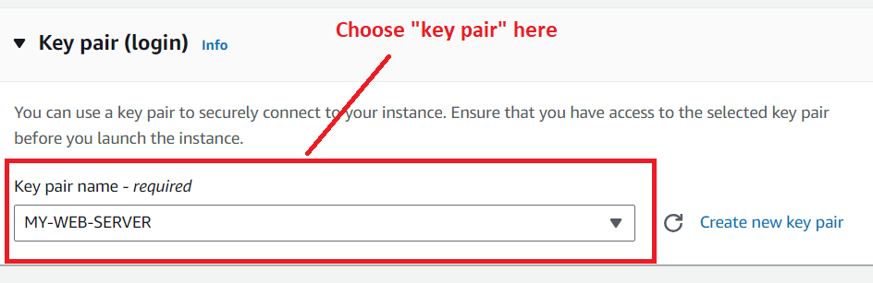

**Step 7: Go** tothe **“Network Settings”** & **click** onthe **“Edit”.**

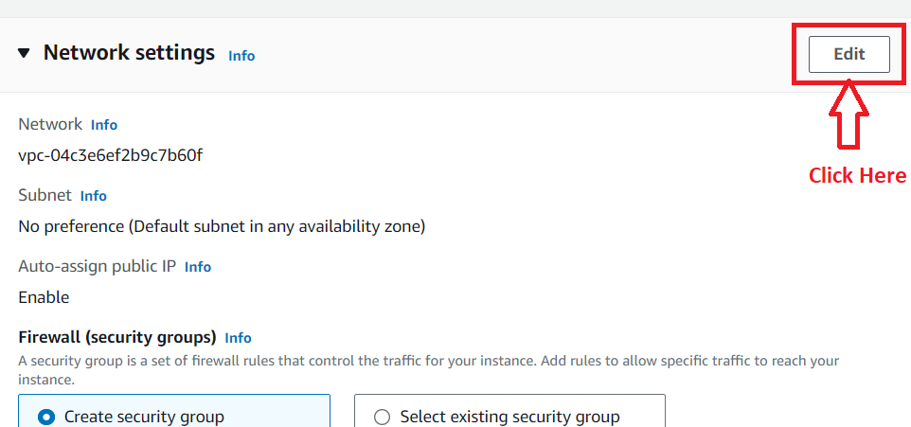

**Step 8: In** the **“Firewall”, choose** the **“Select existing security group”. Select** the **default security group (**sg-0c676fe8f0f9bd8fc), **which you have added during the “FSx Creation”.**

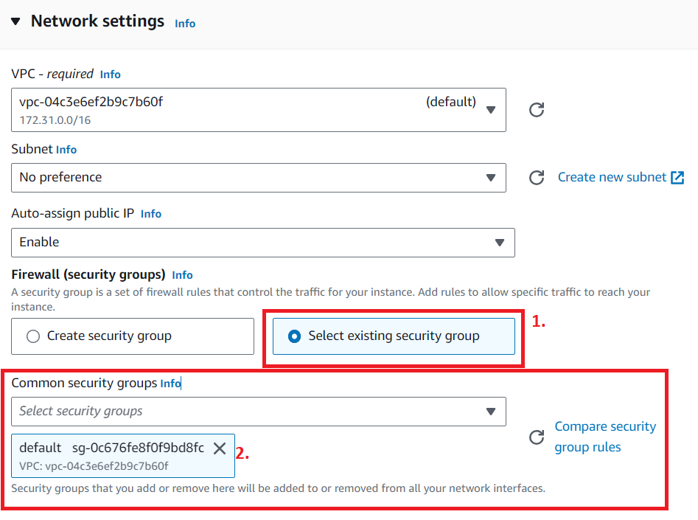

**Step 9: Leave** the **“Configure Storage”** as it is**. Click** on the **“Launch Instance”.**

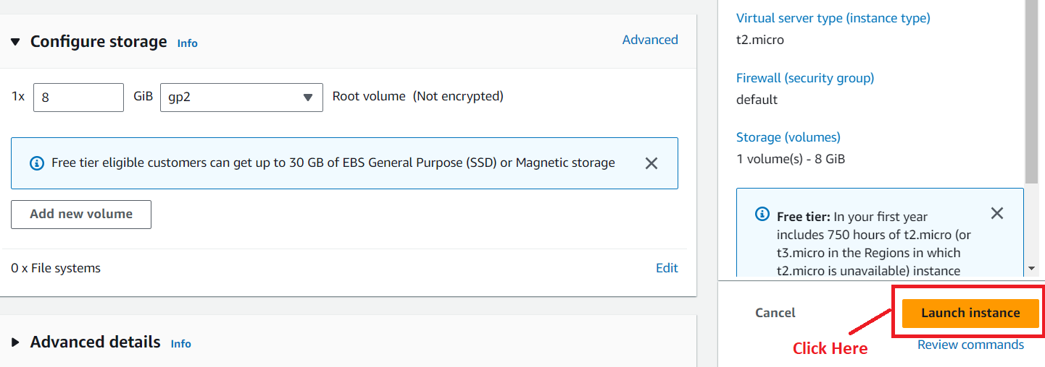

**Step 10: Click** on the **“Hyperlink” (i-08405166ef42bd6de)** & **your instance** will be **shown** in the **“Running” state.**

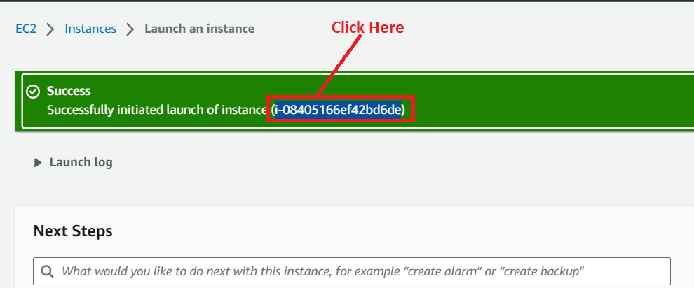

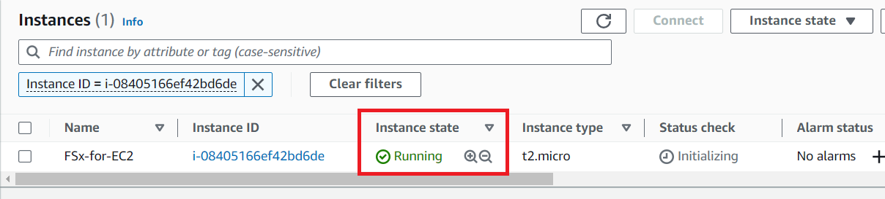

**4. Attach FSx for Lusture with Amazon Linux 2 EC2 Instance**

**Step 1: Go** tothe **“Instances”. Select** the **Instance** & **click** on **“Connect”.**

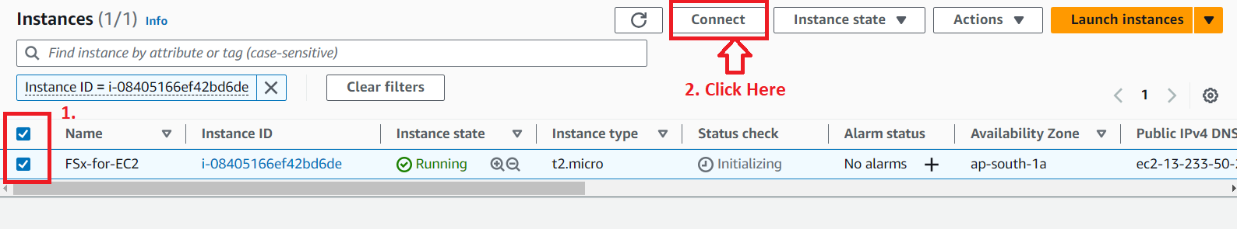

**Step 2: Click** onthe **“Connect”** inthe **“EC2 Instance Connect”.**

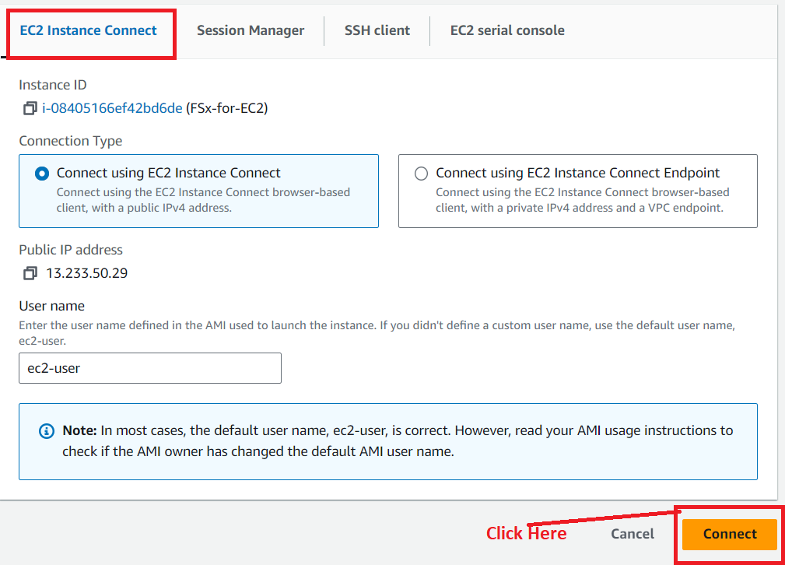

**Step 3: Your EC2 Instance** will be **successfully connected. First run** the **“sudo yum update” command** to **update** the **instance. Press “enter”** from the **keyboard after typing** the **command.**

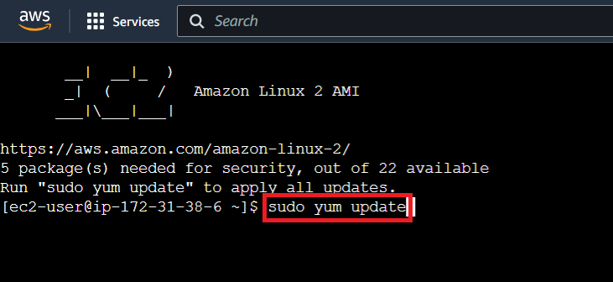

**Step 4: Type “Y” to update the instance. After Typing “Y”, press Enter.**

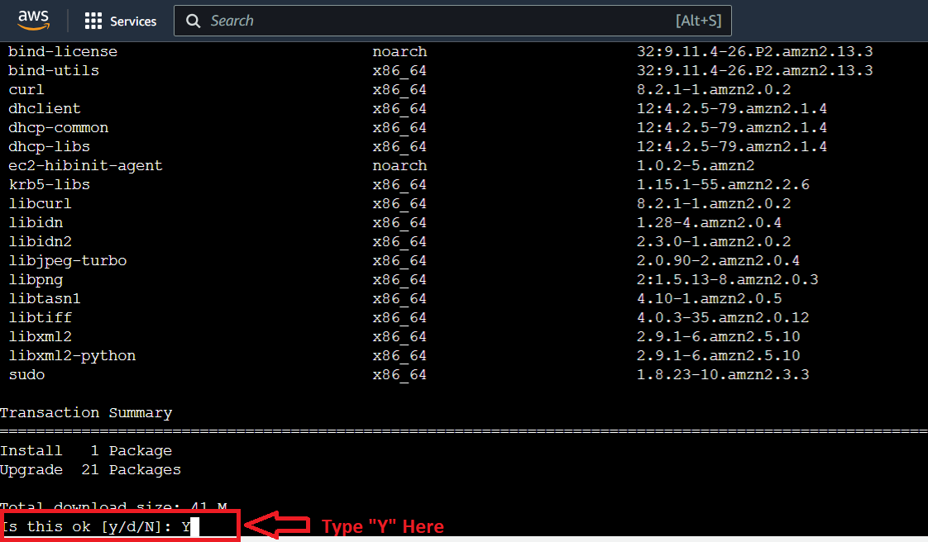

**Step 5: The machine (FSx-For-EC2)** will be **successfully updated.**

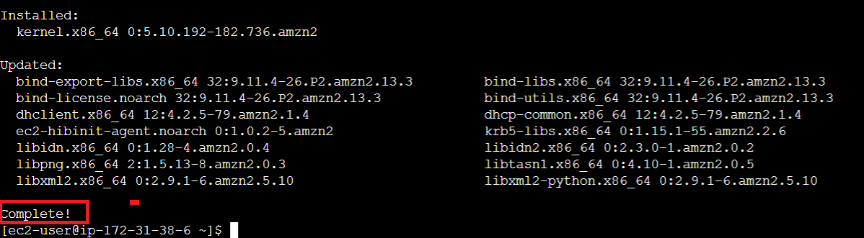

**Step 6: Now, we will Install** the **“Lusture Client”. Use** this **command (sudo amazon-linux-extras install -y lustre2.10)** to **install** the **“Lusture”. Press “enter” from** the **keyboard after typing** the **command.**

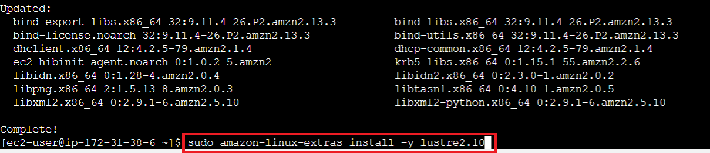

**Step 7:** The **lustre client** will be **successfully installed.**

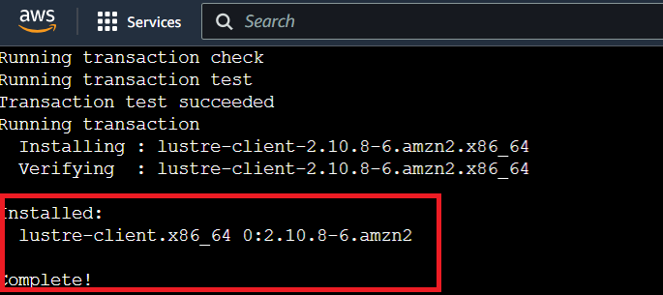

**Step 8: Create** a **directory using** this **command: “sudo mkdir /fsx”.**

**Press “enter” from the keyboard to create the “fsx” directory.**

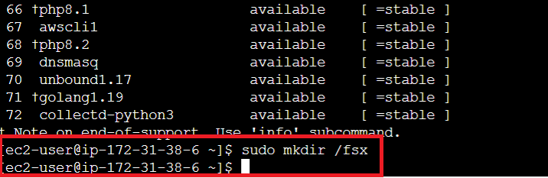

**Step 9: For attaching** the **“FSx”** to **“Amazon Linux 2”, go** to **your “FSx file system”. Click** onthe **“Attach”.**

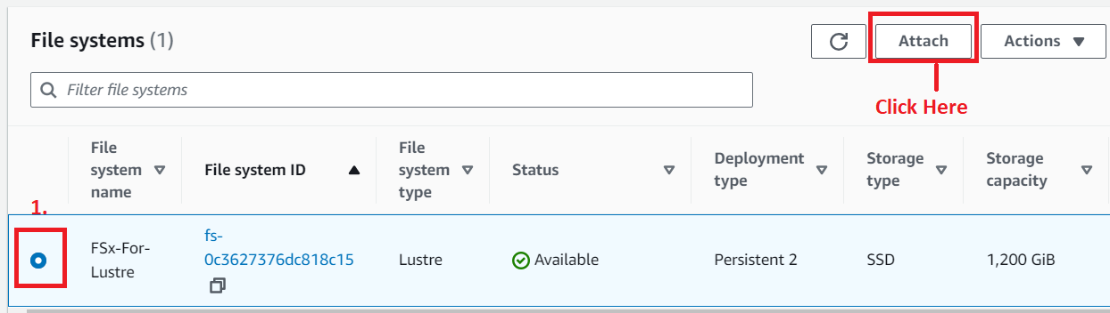

**Step 10: Copy** this **command (“sudo mount -t lustre -o noatime,flock fs-0c3627376dc818c15.fsx.ap-south-1.amazonaws.com@tcp:/s5e3bbmv /fsx”)** from **the “Attach file system”.**

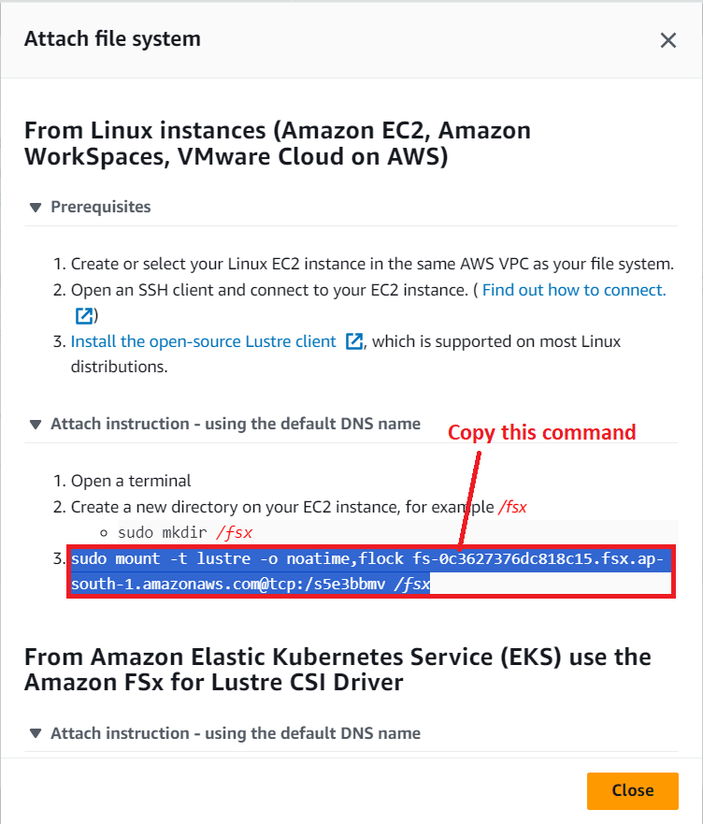

**Step 11: Now paste this command to “Amazon CLI” & Press “Enter” from the keyboard to run the command.**

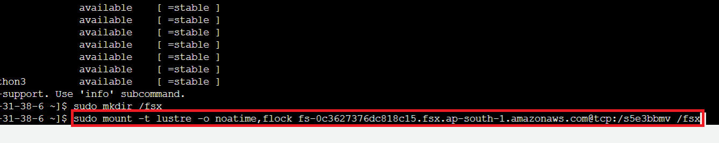

**Step 12: Your FSx mount** will be **successfully builded. To check** the **/fsx directory, use “df -h” command. Your directory will be shown.**

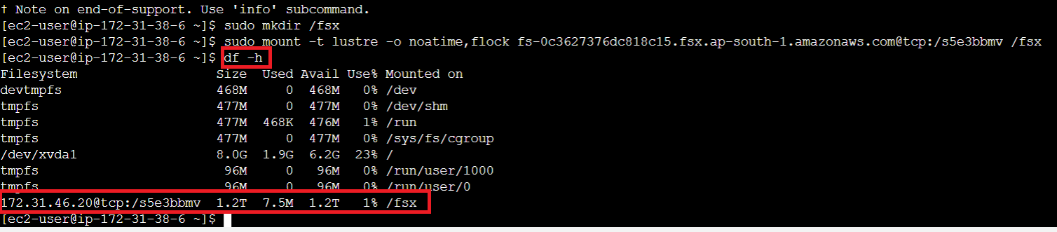

**Step 13: Now go** to the **“/fsx” directory using** the **“cd /fsx” command.**

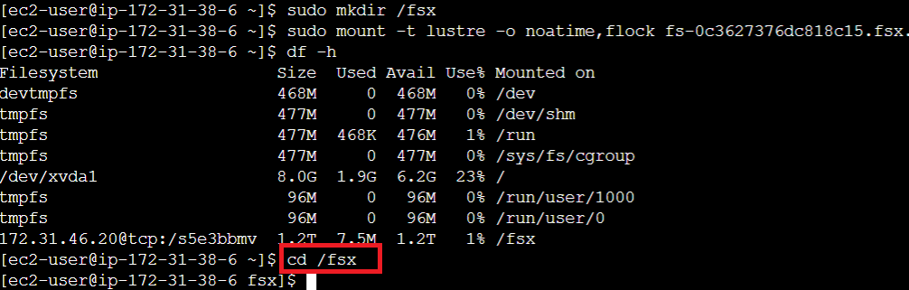

**Step 14: Now, we** will **create** the **“hello.txt” file using** the **“sudo touch hello.txt”.**

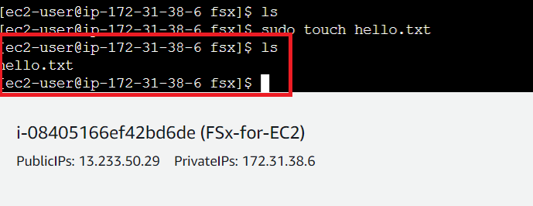

**Step 15: Now, we** will **add** the **content** inthe **“hello.txt”** file **using** the **“sudo nano hello.txt”** command.

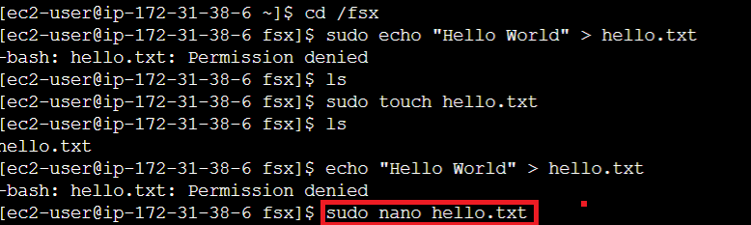

**Step 16: Insert** the **content** & **do the “CTRL+X”** & **Press “Y”** from the **keyboard. Press “enter”** from **keyboard** to **exit** the **file.**

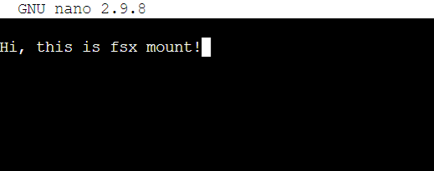

**Step 17: For viewing** the **“hello.txt” file content, type** the **“cat hello.txt” command** & **press “Enter”** from **the keyboard. Your content** will be **shown.**

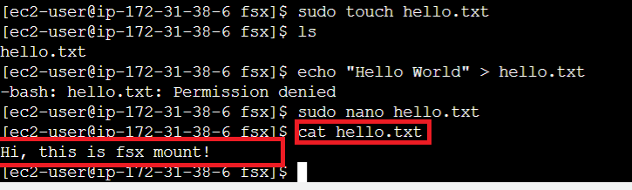

***So this is the complete process to connect the “lustre” with the “Amazon Linux 2”.***